Southern California Bight 2023 Regional Monitoring Program: Submerged Aquatic Vegetation (SAV)
SCCWRP Technical Report

Jill Tupitza, David Gillett, Adriana Le Compte Santiago, Jan Walker

Southern California Coastal Water Research Project, Costa Mesa, CA

March 2026

BIGHT ‘23 SAV COMMITTEE MEMBERS
Member | Affiliation
Chad Loflen | San Diego Regional Water Quality Control Board
Lauren Briggs | Santa Ana Regional Water Quality Control Board
Terri Reeder | Santa Ana Regional Water Quality Control Board
Kat Beheshti | San Onofre Nuclear Generation Station Mitigation Project (SONGS-MP)/UC Santa Barbara
Christine Whitcraft | California State University Long Beach
Lizzie Duncan | NOAA – Channel Islands National Marine Sanctuary
Hannah Lyford | UC Santa Barbara/ NOAA CINMS
Vanessa van Deusen | NOAA – Channel Islands National Marine Sanctuary
Byrant Chesney | NOAA Fisheries
Dan Lawson | NOAA Fisheries
Ken Schiff | SCCWRP

PARTICIPATING LABORATORIES & STAFF
Member | Affiliation
Keith Merkel | Merkel & Associates
Marco Sigala | Moss Landing Marine Lab
William Jakl
Hannah Lyford | UC Santa Barbara
Justin Gill | San Jose State University
Johnathan Casey | Aquarium of the Pacific
Adam Obaza | Paua Marine Research Group

FOREWORD
Citation
ACKNOWLEDGEMENTS

EXECUTIVE SUMMARY

Background
Regional monitoring is an important vehicle for understanding status and trends in aquatic habitat health in the Southern California Bight (SCB). One such important aquatic habitat in Southern California is eelgrass (Zostera spp.), which supports ecosystem functions, and by extension, supports Beneficial Uses and Essential Fish Habitat. Eelgrass plays a unique role in shaping coastal systems both physically and ecologically, as a baffle that stabilizes sediment and sequesters carbon, and a habitat that supports rich biodiversity of invertebrates, fish, and waterfowl (Nordlund et al 2016, Orth et al 1984). Most eelgrass survey efforts across the state, including several regional inventories, focus on area and extent of eelgrass, and site-specific objectives (Merkel & Associates LLC, 2024). This approach does not directly consider the dual nature of SAV, as both an organism as well as a habitat, and the ecosystem functions supported by this complex living entity. Eelgrass presents an opportunity for a bioassessment approach that is tethered to a specific habitat, and is modeled around the functions of that ecosystem, rather than around the organisms that live within the habitat, which is a more common bioassessment approach (Mazor et al 2016; Anderson 2020).

Study Objectives and Approach
This study presents the findings of the first survey of coastal Submerged Aquatic Vegetation (SAV) condition to be included within the Southern California Bight Regional Monitoring Program. This survey was motivated by the need to understand condition of eelgrass (Zostera marina), the dominant species of seagrass in Southern California embayments and estuaries, at a regional perspective and whether condition varies across different embayment types. Data were collected through a multi-agency community of practice, which developed and intercalibrated a series of standard protocols. Sample sites across the Southern California Bight were selected via a random probabilistic sampling design, stratified across three waterbody types – estuaries, small embayments, and large embayments. Beyond the 42 random sites, the survey also included an additional YY17 targeted sites of interest to the participants. The structural measures of 59 eelgrass sites were assessed using the framework proposed by McCune et al 2020. This framework is comprised of conceptual models linking seven key ecosystem functions supported by eelgrass to the structural metrics that are measurable via field and lab surveys. The assessment framework was designed to evaluate the condition of a given site – Poor, Moderate, Good or Excellent – from the perspective of its ability to support specific ecosystem services and functions. The structural metrics of eelgrass beds were combined following the structure-function conceptual models of McCune et al (2020) with the individual functions and overall condition evaluated and scored against a regional expectation of best available reference.

Study Findings
Nearly half (45%) of the area Bight-wide is in Good Condition, and nearly a third (31%) of the remaining area is in Moderate Condition. An approximately equal percent area of the Bight (~11-12%) was in either Excellent or Poor Condition. Eelgrass overall condition did vary slightly across strata, with small embayments with the most area (59%) in Moderate Condition, and large embayments/estuaries largely in Good Condition (48% and 36%), respectively. Each strata had their smallest percentage (less than 15% in all strata) of area in Excellent Condition. Estuaries had the largest area of any stratum (21.41%) in Poor Condition
Carbon Sequestration, Nekton Habitat Utilization, Waterfowl Habitat, and Improving Water Quality each had their largest percent area Bight-wide in Moderate Condition. Substrate Stabilization, Primary Production, and Secondary Production had their highest percent area Bight-wide in Good Condition. Nearly a third of total Bight-wide area was estimated in Excellent Condition for Carbon Sequestration. However, most area in estuaries and small embayments was estimated in Poor Condition for Carbon Sequestration. Most area in estuaries was estimated in Excellent Condition for Waterfowl Habitat.
A major result of this study is the first quantitative application of an eelgrass condition index, which can be used to score individual eelgrass beds based on estimates of the ecosystem functions they support
Other outcomes of this study include successful field intercalibration, standards and protocols co-developed by a community of practice, and suggestions for sampling methodology refinement and future establishment of Data Quality Objectives. We also present a public SAV data portal, which can be used to manage data reporting and facilitate open access to regional data.

Recommendations
BIGHT COMMITTEE TO DISCUSS

Jill & David’s ideas:
- The survey should be repeated as part of the 2028 Southern California Bight Regional Monitoring Program to begin characterizing the spatial and temporal variability in eelgrass condition
- Future eelgrass assessment surveys should be expanded to explicitly include coastal open water Zostera pacifica (broad leaf eelgrass) beds
- An analogous structure-function assessment framework should be developed for other important species of SAV in California (e.g., surf grass (Phyllospadix spp) or widgeon grass (Ruppia maritima))
- Eelgrass condition scores should be mapped directly to achievement of Estuarine beneficial uses / develop a way to contextualize condition results to be used in evaluating success under the CEMP
- Prioritize a series of validation studies for the structure-to-function relationships that benchmark condition categories in real rate processes

Table of Contents
​​
​
​
​
​
​
​
​
​
​
​
​
​
​
​
​
​
​
​
​
​
​
​
​
​
​
​
​
​
​​

List of Figures
Figure 1. Conceptual model of relationships between structural metrics and ecosystem functions of seagrass (McCune et al. 2020).

Figure 2. Schematic depicting the transect and quadrat sampling scheme for different growth forms of eelgrass. A The idealized Bed, B – The Idealized Patch, C – Th e Idealized Fringing Bed, and D – The Idealized Meadow. Any intertidal portions of given location were omitted from sampling.

Figure 3. PHOTO

Figure 4. Percent area estimates (with 95% confidence intervals) of overall eelgrass condition score by stratum. The points represent area estimates and the error bars represent the strata-based confidence intervals.

Figure 5. Geographic distribution of overall eelgrass condition throughout the Southern California Bight. The legend shows point color corresponding to overall eelgrass condition categories.

Figure 6. Percent area estimates (with 95% confidence intervals) of the seven ecosystem function scores in each of the four condition categories. Points represent area estimates, and error bars represent strata-based confidence intervals.

Figure 7. Percent area estimates (with 95% confidence intervals) of each of the seven ecosystem function scores in each of the four condition categories. Points represent area estimates and error bars represent strata-based confidence intervals.

Figure 8. Non-metric multidimensional scaling plot of ecosystem function scores at each waterbody. Points represent centroids from multiple sites at each waterbody. Points and ellipses are both color-coded by waterbody. Ellipses represent 95% of the data for each waterbody. Stress = 0.041.

Figure 9. Total Suspended Solids (TSS) in milligrams per 500 mL water versus water quality ecosystem function scores. TSS data was not available for all sites. Geom_smooth() represents the 95% confidence interval for this observed relationship.

Figure 10. Overall eelgrass index scores with distance to inlet (km).

Figure 11. Overall eelgrass condition scores by nominal site protection status. P = “protected”, “U” = unprotected. Protected sites include areas within designated Marine Protected Areas (no take, limited take, State Marine Reserves, State Marine Conservation Areas). Unprotected sites are areas that are not protected from take in some way, including National Wildlife Refuges. Significant difference between groups via Wilcox test (p = 0.049).

Figure 12. Geographic distribution of estimated water quality ecosystem function throughout the Southern California Bight. The legend shows point color corresponding to water quality condition categories.

Figure 13. Eelgrass structural metrics from the Southern California Bight in 2023-2024. The midline of each box represents the median value for each structural metric. The upper and lower bounds of the box represent the interquartile range (IQR, 25th and 75% percentiles of data), whiskers are 1.5 x IQR for each metric, and anything outside that range is plotted as an outlier point.

Figure 14. Top: Boxplots of probabilistic sites’ overall condition scores, with targeted sites as points and the median of overall condition score of targeted sites as a pink X. Bottom: Boxplots of probabilistic sites’ ecosystem functions scores, with targeted sites as points and the median of each ecosystem function score of targeted sites as a pink X. The midline of each box represents the median score of probabilistic sites, the IQR is the 25th and 75th percentiles of score data, and the whiskers are 1.5 x IQR.

Figure A1. Eelgrass structural metric data by stratum – part 1.

Figure A2. Eelgrass structural metric data by stratum – part 2.

Figure C1. Geographic distribution of estimated nekton habitat ecosystem function throughout the Southern California Bight. The legend shows point color corresponding to overall eelgrass condition categories.

Figure C2. Geographic distribution of estimated waterfowl habitat ecosystem function throughout the Southern California Bight. The legend shows point color corresponding to overall eelgrass condition categories.

Figure C3. Geographic distribution of estimated carbon sequestration ecosystem function throughout the Southern California Bight. The legend shows point color corresponding to overall eelgrass condition categories.

Figure C4. Geographic distribution of estimated substrate stabilization ecosystem function throughout the Southern California Bight. The legend shows point color corresponding to overall eelgrass condition categories.

Figure C5. Geographic distribution of estimated primary production ecosystem function throughout the Southern California Bight. The legend shows point color corresponding to overall eelgrass condition categories.

Figure C6. Geographic distribution of estimated secondary production ecosystem function throughout the Southern California Bight. The legend shows point color corresponding to overall eelgrass condition categories.

Figure D1. Non-metric multidimensional scaling plot of ecosystem function scores at each waterbody. Points represent centroids from multiple sites at each waterbody. Points and ellipses are both color-coded by waterbody. Ellipses represent 95% of the data for each waterbody. Stress = 0.041.

Figure D2. Log₁₀ – transformed chlorophyll a concentrations with overall eelgrass index scores. Chlorophyll data was not available for all sites. No significant relationship was observed.

Figure D3. Overall eelgrass condition scores by nominal site protection status. P = “protected”, “U” = unprotected. Protected sites include areas within designated Marine Protected Areas (no take, limited take, State Marine Reserves, State Marine Conservation Areas). Unprotected sites are areas that are not protected from take in some way, including National Wildlife Refuges. T-test comparisons indicate no significant differences between protection status in any stratum.

Figure D4. Overall eelgrass condition scores by specific site protection status. “No Take” = MPAs with no take, “Limited Take” = MPAs with limited take regulations, not including scientific collection, “NWR” = National Wildlife Refuges, “U” = unprotected. Wilcox test shows a significant (p = 0.02) difference between NWR and Unprotected sites.

Figure D5. Overall eelgrass condition scores by specific site protection status. “No Take” = MPAs with no take, “Limited Take” = MPAs with limited take regulations, not including scientific collection, “NWR” = National Wildlife Refuges, “U” = unprotected. Wilcox test shows a significant (p = 0.0089) difference between NWR and Unprotected sites in estuaries only.

List of Tables
Table 1. List of sites, waterbodies, and site selection method.

Table 2 Eelgrass plant and bed-scale metrics measured as part of this protocol and which step details their collection.

Table 3. QA/QC summary based on submitted data. Exercise in gathering information about the nature of errors that arise in a community of practice.

Table 4. Lessons learned from field based on Bight ‘23 SAV Committee feedback.

Table B1. Site by site ecosystem function scores and overall eelgrass condition scores.

Table B2. Overall eelgrass condition scores by waterbody

Table B3. Percent area-weighted ecosystem function scores by stratum, including upper and lower 95% confidence intervals.

Table B4. Percent area-weighted overall eelgrass condition scores by stratum, including upper and lower 95% confidence intervals.

Table B5. Percent area-weighted estimated ecosystem function scores for the overall Bight, including upper and lower 95% confidence intervals.

- Introduction
Seagrass is widely acknowledged as an essential coastal resource worldwide, as it supports ecologically, economically, and culturally important functions as both an organism as well as a habitat. Four different taxa (Zostera marina, Zostera pacifica, Ruppia maritima, and Phyllospadix sp.) are endemic to Southern California, but Zostera, the genus known as eelgrass, is dominant in estuaries and embayments throughout the region (Bernstein et al. 2011). Zostera marina, in particular, is the most common.

Eelgrass is a habitat forming taxa, stabilizing sediment in shallow areas to create a matrix of blades extending into the water column, and a network of rhizome growth belowground. This structurally complex habitat facilitates immense secondary and tertiary production relative to adjacent bare sediments by shielding benthic fauna and juvenile fish from marine predators and providing abundant autochthonous food from the grass itself and the associated epiphytic microalgae (Heck et al. 2003, Cimon et al. 2021). In many locations along the West Coast US, eelgrass habitat supports the migration of anadromous fish, including several species of salmonids (Simenstad 1994). It also supports both a resident populations of waterfowl as well as migratory birds during critical periods of migration. Birds nest adjacent to eelgrass habitat, and forage fish, benthic fauna, eelgrass epiphytes, and eelgrass itself, making it a critical habitat for Southern California wildlife.

Eelgrass occupies hundreds of acres of shallow, soft-bottom coastal habitat in Southern California, though the exact extent is currently undefined (Sherman & DeBruyckere 2018). Ephemeral shifts in acreage occur year-to-year, as the plant grows both asexually through its rhizomes as well as sexually through its flowering period in the late summer, responding to a suite of environmental conditions, especially irradiance/depth and temperature (Cabello-Pasini et al 2003, Sherman & DeBruyckere 2018). Eelgrass can impact local conditions in any given body of water, but it can also serve as an efficient vehicle for carbon storage, in the face of global climate change (Friess et al. 2024).
Ecosystems supported by eelgrass face threats in the Southern California region, including pressure from a highly developed coastline, pollution, dredging, invasive species, and a host of anthropogenic activities that range from recreation to extractive industry. These threats, along with the geomorphological, chemical, and ecological complexity of the habitats occupied by eelgrass, are best understood through the perspective of the ecosystem functions eelgrass provides.

Traditional condition assessments either focus on a resource (i.e. benthic fauna, nekton) or a habitat (i.e. kelp, seagrass). In the case of the resource, estimates of condition are usually surveys of either community measures (species richness, abundance, health, or size)e (Borja et al. 2008). In the case of the habitat, which is how seagrass is generally classified, estimates of condition are often based on areal or volumetric extent, presence-absence (De Clippele et al. 2017; Whitcraft et al. 2025; BIOVOLUME CITATION). Due to the dual nature of eelgrass as both a resource and a habitat, we use a condition assessment that considers ecosystem function rather than direct measures of either a resource or a habitat (Gillett et al. 2026). Estimating supported ecosystem functions is perhaps the most salient way to measure the value of eelgrass given its multifaceted benefits in coastal systems (Bernstein et al. 2011; McCune et al. 2020)

An eelgrass bed may inhabit an estuary or embayment and provide the ecosystem functions identified above within the context of that habitat. Ecosystem function of eelgrass may naturally vary within the estuarine habitat based the physical and chemical features that control eelgrass growth and health, such as estuarine circulation, turbidity, temperature, and depth (Blake & Duffy, 2016). This may represent the baseline or reference condition for a given type of estuary (small embayment, large embayment, estuary). If that same eelgrass bed in then invaded by Caulerpa, a genus of invasive macroalgae, which has been actively managed in Newport Bay and San Diego Bay, ecosystem function may be dampened (Anderson, 2005; SCCAT, 2021). In all likelihood, any given eelgrass bed is also under threat of multiple, potentially interacting stressors that are challenging to measure directly, including those at the global scale (climate change impacts such as sea temperature rise and ocean acidification) and local (pollution from stormwater and wave exposure from boating) (Hughes et al. 2017; Cimon et al. 2021). A management tool that estimates ecosystem function has been frequently requested by interested parties for this purpose: to understand how eelgrass condition functions within the context of its habitat and how that condition is dampened by stress (Bernstein et al. 2011).

Regulatory programs have provided a framework for protection of eelgrass from coastal development activities, such as dredging and filling. The California Eelgrass Mitigation Policy (CEMP) directs that there should be “...no net loss of eelgrass functioning...” (NOAA National Marine Fisheries Service, 2014), which has been a policy tool for both protecting eelgrass from wanton destruction and enabling mitigation projects throughout the state. Moreover, eelgrass provides Essential Fish Habitat under the Magnuson-Stevens Act, but requires extensive information on how fish species are supported to garner federal conservation efforts. Eelgrass also supports Beneficial Uses designated by the California State Water Resources Control Board, including Spawning, Reproduction, and/or Early Development (SPWN), Estuarine Habitat (EST), and Wildlife Habitat (WILD). These policies emphasize ecological function and benefits of eelgrass, rather than structural characteristics of eelgrass, highlighting the need for monitoring data and tools for management that yield insight on eelgrass ecological functions. Measuring ecosystem function of eelgrass directly is not practical at the regional scale, but can be systematically estimated by metrics of eelgrass structure and composition (McCune et al. 2020; Merkel and Associates 2024).

The Bight Regional Monitoring Program demonstrates a coordinated effort to advance eelgrass monitoring and assessment across Southern California. Based on recommendations from an expert panel of scientists, regulators, and interested parties (Bernstein et al. 2011), this study applies a regional monitoring framework designed to address key management questions related to eelgrass condition. This study adopts a tier-3 assessment approach (Gillett et al. 2018; McCune et al. 2020), which evaluates ecosystem functions based on their relationships with measurable structural attributes of eelgrass. We use the condition assessment approach developed in Gillett et al. 2026 to evaluate eelgrass condition using regional monitoring data. Our goals for building and using this assessment tool addressed two central questions:

- What is the regional condition of eelgrass in the Southern California Bight?

- Are there differences in condition or ecosystem function between strata (small embayments, large embayments, estuaries)?

- Methods

Study Design
A stratified probabilistic sampling approach was used to sample eelgrass beds throughout the Southern California Bight such that inferences may be drawn from the sampled population of eelgrass to the true population of eelgrass. A base map layer from Point Conception, CA to the US-Mexico border was generated from previous surveys of eelgrass beds across the region from 2015-2022 (Merkel and Associates, 2016; Merkel and Associates 2023). This base map was augmented with waterbody-by-waterbody site visits focusing on smaller, heretofore under sampled embayments in the northern parts of the Southern California Bight (e.g., Hollister Ranch lagoon, Gaviota estuary, Refugio estuary) looking for eelgrass in the summer of 2022. These small embayments were surveyed for the presence of eelgrass by paddling and snorkeling (when practical) their waters, recording the presence and type of any SAV that was observed. These observations were then digitized into polygons for inclusion into the base map. Lastly, the base map was amended following consultations with local seagrass experts across the region. All of these eelgrass extent and presence data were combined into a single GIS data layer from which sample sites could subsequently be selected. (https://sccwrp.maps.arcgis.com/apps/webappviewer/index.html?id=fbd66a9bc6174ad7a5cf90b3d5b9405c).
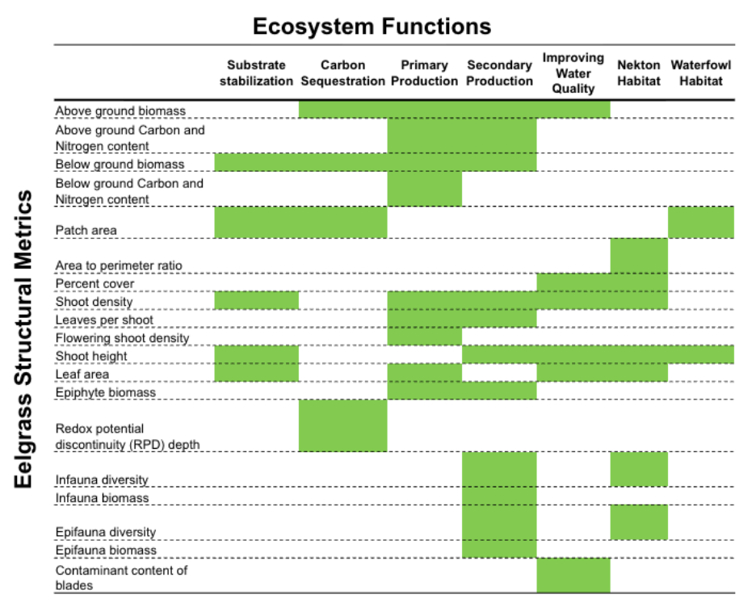
Figure 1. Conceptual model of relationships between structural metrics and ecosystem functions of seagrass (McCune et al. 2020).

Each waterbody along the Southern California Bight was binned into one of three strata prior to sampling based upon a combination of environmental setting (Doughty 2019) and local knowledge.
- Large embayments – Enclosed or semi-enclosed waterbodies greater than 8 km² in area that have a permanent connection to the open ocean (e.g. San Diego Bay, Lower Newport Bay).
- Small embayments – Enclosed or semi-enclosed waterbodies less than 8 km² in area that have permanent connections to the open ocean (e.g. Newport Back Bay, Marina del Ray).
- Estuaries – Small enclosed waterbodies with a distinct connection to upland freshwater sources and permanently maintained or seasonal/ephemeral connection to the open ocean (Anaheim Bay, Batiquitos Lagoon).
The sample draw was stratified to help ensure that there was relatively even representation of waterbodies across the region. Without stratification, the majority of randomly selected sites would likely occur in the region’s largest eelgrass habitats (i.e., San Diego Bay and Mission Bay). The sample frame of the previously observed eelgrass area in each stratum was divided into 500m² cells that would represent a potential sample site. Ten sample sites were randomly selected without replacement from each stratum (30 in total) using the sample_strat function in the R package spSurvey (v5.5.1) (Dumelle et al. 2023). Given the ephemeral nature of eelgrass aggregations that expand and contract in extent from year to year, 30 additional sites were identified for each stratum to serve as replacement sites (i.e., overdraw sites) in case any of the initial 10 sample sites did not have any vegetation in 2024. Eleven additional sites of special concern were identified according to management priority, after the probabilistic sample draw. These sites were surveyed and then assigned a stratum based on their respective waterbodies.

Table 1. List of sites, waterbodies, and site selection method.
waterbody | masterid | stratum | site selection
Agua Hedionda Lagoon | 904AHT001 | estuary | probabilistic
Batiquitos Lagoon | 904BLT001 | estuary | probabilistic
Mission Bay | 906MBECSR | large_embayment | probabilistic
Mission Bay | 906MBMCSC | large_embayment | probabilistic
Mission Bay | 906MBVCSA | large_embayment | probabilistic
Mission Bay | 906MBVINC | large_embayment | probabilistic
Mission Bay | 906MBVIYP | large_embayment | probabilistic
San Diego Bay | 910ZNJN01 | large_embayment | probabilistic
San Diego Bay | 910ZNJN02 | large_embayment | probabilistic
San Diego Bay | 912SDBCPB | large_embayment | probabilistic
San Diego Bay | 912SDBSLB | large_embayment | probabilistic
San Diego Bay | 912SDCBVP | large_embayment | probabilistic
San Diego Bay | 912SDNOST | large_embayment | probabilistic
San Diego Bay | 912SDSBPO | large_embayment | probabilistic
San Diego Bay | 912SDSIWB | large_embayment | probabilistic
San Diego Bay | 912SDSSSC | large_embayment | probabilistic
San Diego Bay | 912SDT001 | large_embayment | probabilistic
San Diego Bay | 912SDT003 | large_embayment | probabilistic
Santa Ana River | B23-SAV-001 | estuary | probabilistic
Batiquitos Lagoon | B23-SAV-002 | estuary | probabilistic
Seal Beach NWR (Case Pond) | B23-SAV-005 | estuary | probabilistic
Seal Beach NWR | B23-SAV-006 | estuary | probabilistic
Batiquitos Lagoon | B23-SAV-007 | estuary | probabilistic
Agua Hedionda Lagoon | B23-SAV-008 | estuary | probabilistic
Seal Beach NWR | B23-SAV-009 | estuary | probabilistic
Port of Los Angeles | B23-SAV-011 | small_embayment | probabilistic
Huntington - Magnolia Marsh2 | B23-SAV-012 | small_embayment | probabilistic
Magnolia Marsh | B23-SAV-012 | small_embayment | probabilistic
Newport Bay | B23-SAV-014 | small_embayment | probabilistic
Port of Los Angeles | B23-SAV-015 | small_embayment | probabilistic
Newport Bay | B23-SAV-018 | small_embayment | probabilistic
Port of Los Angeles | B23-SAV-020 | small_embayment | probabilistic
San Diego South Bay | B23-SAV-022 | large_embayment | probabilistic
San Diego Bay | B23-SAV-023 | large_embayment | probabilistic
Newport Bay | B23-SAV-025 | large_embayment | probabilistic
San Diego Bay | B23-SAV-026 | large_embayment | probabilistic
San Diego South Bay | B23-SAV-027 | large_embayment | probabilistic
San Diego Bay | B23-SAV-029 | large_embayment | probabilistic
San Diego South Bay | B23-SAV-030 | large_embayment | probabilistic
Newport Bay | B23-SAV-031 | small_embayment | probabilistic
Bolsa Chica | B23-SAV-032 | estuary | probabilistic
Batiquitos Lagoon | B23-SAV-035 | estuary | probabilistic
San Diego Estuary | B23-SAV-036 | estuary | probabilistic
San Dieguito Lagoon | B23-SAV-060 | estuary | probabilistic
Magnolia Marsh | B23-SAV-063 | small_embayment | probabilistic
Port of Los Angeles | B23-SAV-064 | small_embayment | probabilistic
Dana Point Harbor | B23-SAV-066 | small_embayment | probabilistic
Mission Bay | B23-SAV-092 | large_embayment | probabilistic
Alamitos Bay | B23-SAV-901 | small_embayment | targeted
Alamitos Bay | B23-SAV-902 | small_embayment | targeted
Alamitos Bay | B23-SAV-903 | small_embayment | targeted
Alamitos Bay | B23-SAV-904 | small_embayment | targeted
San Diego Bay (Zuniga Jetty) | B23-SAV-905 | large_embayment | targeted
Mission Bay | B23-SAV-906 | large_embayment | targeted
San Elijo Lagoon | B23-SAV-907 | estuary | targeted
Mission Bay | B23-SAV-908 | large_embayment | targeted
King Harbor | B23-SAV-909 | small_embayment | targeted
Oceanside Harbor | B23-SAV-910 | small_embayment | targeted
La Jolla Cove | B23-SAV-991 | NA | targeted
Santa Cruz Island | B23-SAV-Santa Cruz Island | NA | targeted

Field Collection of Structural Metrics
Field protocols for sampling are fully detailed in McCune et al. (2020) and the Bight 2023 SAV Workplan. All in-water measurements and collection of material were conducted by teams of SCUBA divers and any intertidal portions of a location were omitted from sampling. If seagrass was present at a site, the perimeter of the aggregation was measured. For every ten beds, a random bed was chosen for a second measurement, as a field replicate. Plants were considered to be of the same aggregation if there was less than 3m of bare sediment between plants. Eelgrass was classified into different growth categories:

- Patch: a discrete aggregation of plants that is approximately 3m or less along its longest axis.
- Bed: a discrete aggregation of plants that is greater than 3m and less than 75m along its longest axis.
- Meadow: an expansive aggregation of plants that is greater than 75m along its longest axis and more than 20m along its shortest/shallow-to-deep axis.
- Discrete aggregation: a grouping of above ground plants separated from other groupings by approximately 3m or more of bare/unvegetated sediment

Transects were laid across each bed according to bed growth categories. For the ideal bed, three transects (Inner, Mid, Outer) were laid along along the longest axis, nominally parallel to the shoreline, and one transect (Cross) was laid from the shallow-to-deep axis of the bed. The Inner and Outer transects were laid approximately 1m inside the closest edge of the bed. The Mid transect was laid directly across the middle, and to the degree possible, leaving approximately 3m between the Inner and Outer transects (Figure 2). The Cross transect was placed to orthogonally bisect the three other transects. Percent cover of seagrass and percent floating macroalgae were visually estimated using 0.25 m² quadrats. Shoot density and flowering shoot density were also estimated in this way. Flowering shoot density was measured as the number of shoots within a quadrat with distinct spathes (leaf structure enclosing flowers) present on their apical ends. Five quadrats were measured at equidistant points across the Mid transect. Three additional quadrats were measured at approximately equidistant points along the Inner and Outer transects. Up to five transects were measured along the Cross transect, as the distance allowed. Core/ring (10 cm diameter) samples were taken at five locations in the center of each quadrat, collecting both above and belowground parts of the plants (shoots, rhizomes, epiphytes), at five locations, as shown on Figure 1. Below ground material was gently rinsed to remove excess sediment. Adjustments to this method were made according to bed growth category. No transects were laid at patches unless they had an axis longer than 3m, but two quadrats were haphazardly measured and cores were collected from within both quadrats. One Mid and one Cross transect were laid at patches larger than 3m, with five quadrats laid along the Mid transect and three quadrats laid along the Cross transect, with four total samples were taken from those quadrats, one occurring at the intersection of the two transects. Meadows received the same sampling scheme as an ideal bed, except that a perimeter was drawn within the bed with the approximate dimensions of an ideal bed (50m x 20m). Narrow beds were limited to two shoreline parallel transects and one Cross transect, and fringing beds were limited to one shoreline parallel transect and no Cross transect, as appropriate given the length of the shallow-to-deep axis of the bed. For further details, schematics, and SOPS, refer to the B23 SAV Workplan document.

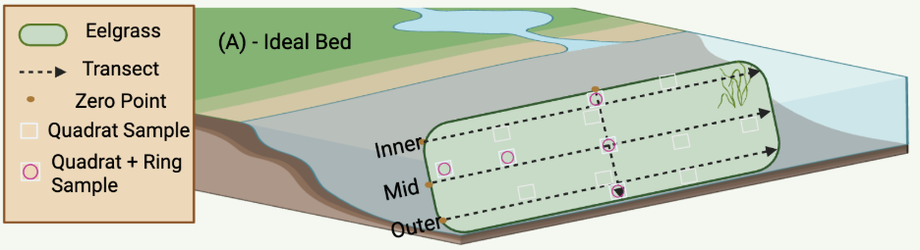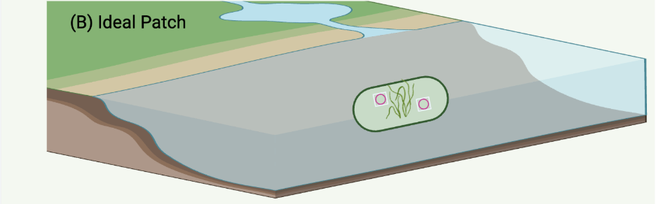
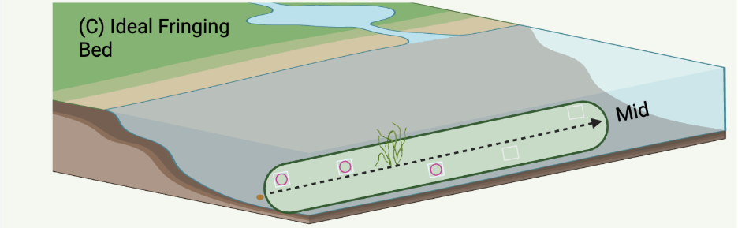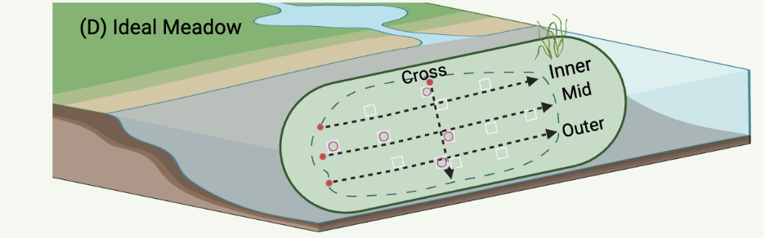
Figure 2. Schematic depicting the transect and quadrat sampling scheme for different growth forms of eelgrass. A The idealized Bed, B – The Idealized Patch, C – The Idealized Fringing Bed, and D – The Idealized Meadow. Any intertidal portions of given location were omitted from sampling.

Laboratory Measurement of Structural Metrics
Within the above ground material from a given site and quadrat, the total number of shoots and the number of leaves per shoot were recorded. All epiphytic material was gently removed from each leaf with a scalpel or glass microscope slide and pooled together for biomass measurement. The length of the of the longest leaf within each shoot was recorded as shoot height and the width of that longest leaf was recorded as shoot width. The total area of all the leaves in each shoot was measured with a leaf area meter (LI-COR™ LI-3100C Area Meter) or a calibrated benchtop scanner and ImageJ image analysis software (https://imagej.net/ij/) and recorded as leaf area. All epiphytic tissues, above ground eelgrass tissue, and below ground eelgrass tissue were blotted dry and measured for wet mass. Each type of tissue was then dried at 60°C for 48 hours and measured for dry mass. A subsample of approximately 2.5 - 3 mg was clipped from each dried tissue sample to measure TOC/TN. Dried samples were subsequently combusted at 500°C for 8 hours and measured for ash free dry mass. The mass of each TOC/TN subsample was multiplied by the ash:dry mass ratio to produce a corrected AFDM for each tissue type, to correct for the removal of tissue. Further details, including SOPs used in this study and proposed for future studies, can be found in the B23 SAV Workplan document.

Table 2. Eelgrass plant and bed-scale metrics measured as part of this protocol and which step details their collection.
Metric | Field or Lab Data Generation | SOP Step
Above Ground Biomass | Lab | Step 19
Above Ground C & N | Lab | Step 21
Bed Perimeter | Field | Step 4
Below Ground Biomass | Lab | Step 19
Below Ground C & N | Lab | Step 21
Epiphyte Biomass | Lab | Step 16
Leaf Area | Lab | Step 18
Leaves per Shoot | Lab | Step 17
Percent Cover | Field | Step 7-3
Sediment C & N | Lab | Step 21
Shoot Density | Field and Lab | Steps 7-4 & 14
Shoot Height | Field and Lab | Steps 7-5 & 15

Condition Assessment
Eelgrass condition was quantified using the framework outlined in McCune et al. 2020 (Figure 1) and refined in Gillett et al. (2026). This framework uses a “best available” approach to defining reference condition (Stoddard et al. 2006, Hawkins et al. 2010) due to the pervasive alteration of coastal habitat in the region, which make the identification of minimally disturbed eelgrass sites to use as a benchmark difficult. Consequently, this approach to setting condition thresholds uses a regional population of eelgrass structural measures as a point of comparison for evaluating a given site. Structural measures (table 2) from the present survey (59 sites) and those of Gillett et al. (2026) (30 sites) were used to define the population distributions of each structural metric.

In brief, individual eelgrass structural metric measurements (e.g. shoot height, shoot density, leaf area) were averaged within each site to create a metric value. The metric values for a given site were then scored relative to their position within the regional population (1 = lowest quartile, 4 = highest quartile). These quartile scores for structural metrics were then combined (arithmetic mean) for each of the seven ecosystem
functions (Primary Production, Carbon Sequestration, Substrate Stabilization, Secondary Production, Nekton Habitat, Waterfowl Habitat, Water Quality) following Figure 1 to produce Ecosystem Function scores for a given site. Ecosystem function scores (1-4) were then binned into four categories Poor, Moderate, Good, Excellent: scores 1.00 to 1.75 = Poor; scores 1.76 to 2.50 = Moderate; scores 2.51 to 3.25 = Good; score 3.26 to 4 = Excellent. All seven ecosystem function scores were then averaged together for each site to produce an Overall Condition score, which was binned into the same four condition categories used for the individual functions.

Additional Analyses
Area-weighted estimates of Overall Condition and seven Ecosystem Function Conditions were calculated using the cat_analysis() function in R ‘spsurvey’ package (Dumelle et al. 2023, v5.6.0). Area estimates and 95% confidence intervals were calculated for each stratum using strata-based area weights from sample draw information, and the Horvitz-Thompson estimator (Horvitz 1952). Targeted sites were assigned a stratum according to the area weight of their respective waterbody before estimates were made.

We explored the responsiveness of the eelgrass condition index based stressor exposure and environmental setting. Data from concurrently taken water samples measured for Total Suspended Solids (TSS) and chlorophyll a were used to evaluate index response to stress from turbidity/reduction of available light. Water samples (500 mL) were collected from the surface at certain sites for TSS and Chlorophyll a. Samples were filtered in the field through pre-weighed GFF filters using a hand pump. All filters were held on ice in the dark during transport back to the lab. For TSS, filters were weighed wet upon arrival, dried at 103°C until a constant weight was reached, and reweighed (EPA 160.2). TSS was calculated based on the difference of the dry weight minus the pre-weight of the filter, in milligrams (mg). For Chlorophyll, filters were extracted for 18-24hr in 90% acetone and then read on a calibrated fluorometer to obtain the concentration of chlorophyll a in µg/L, according to a modified EPA 455 (Welschmeyer 1994). Dilutions were made for RFU > 200 µg/L. The effect of TSS and log₁₀ Chl a on Overall Eelgrass Condition scores and all function scores were evaluated separated using a series of simple linear regressions: lm() in the R ‘stats’ package (v.4.5.2). For example: chla_model <- lm(log10(chla_conc) ~ overall_score, data = all_data).

Non-metric multidimensional scaling based on a Euclidean distance matrix of the seven individual function scores at each site using vegdist() and metaMDS() in R ‘vegan’ package (Oskanen et al 2022, v.2.7-2). Each site was plotted in two-dimensional space, with vectors for each function calculated based on envfit() from R ‘vegan’ package (Oskanen et al 2022, v.2.7-2). Ellipses that encompass 95% of sites (points) at each level (waterbody) were drawn using R ‘ggplot2’ package (v.4.0.2). Centroids were also plotted based on the mean NMDS1 and NDMS2 values for each waterbody.

Distance from nearest ocean inlet for each site was used as an integrative proxy variable to capture both anthropogenic upland influence (i.e., elevated water column nutrients, contaminants, and sediment concentrations) and reduced circulation (i.e., elevated water temperature, reduced dissolved oxygen, and more variable salinity) impacts to the eelgrass. Distance to inlet (km) was characterized “as the fish swims” using ArcGIS Pro (version 3.6.0). The effect of distance to inlet on Overall Eelgrass Condition score was evaluated using a simple linear regression as described above. The effect was further evaluated by stratum. It was hypothesized that locations closer to an ocean inlet would be less stressful to eelgrass (e.g., better water clarity, cooler, more saline water) than those located further inland within their embayment.

Protection status of a site was used a proxy measure for direct physical interaction stress (e.g., anchoring, dredging, recreational harvest). Site protection categories were determined by overlaying the site coordinates with California Department of Fish and Wildlife’s Interactive MPA (Marine Protected Area) Map. Each eelgrass sample site was categorized, in decreasing level of protection, as either “No Take”, “Limited Take” or “Unprotected”, based on activities permitted in each MPA. A few remaining sites were categorized as “National Wildlife Refuge. The effect of protection status on Overall Eelgrass Condition scores was evaluated using pairwise comparisons (Mann-Whitney U). It was hypothesized that the level of site protection may be reflected in the estimated eelgrass condition, either due to protections creating better conditions for eelgrass habitat, or eelgrass habitat in a priori good condition receiving protections.

- Quality Assurance and Quality Control
The goal of the QA/QC effort explored in this first round of data collection across the Southern California Bight was to ensure the data generated by study participants was comparable and complete. Through quality control practices such as field intercalibration, field and lab resampling, and error tracking, we ensure high data quality for subsequent analyses. Each quality control practice is summarized in the subsections below. Full details can be found in the B23 SAV Workplan.

Field
Before data collection in 2023, a field intercalibration was hosted in April 2024 to ensure quality of visual data recorded was consistent across participating laboratories. Labs included CSULB, NOAA Fisheries, Merkel & Associates, LLC, Moss Landing Marine Lab, Paua Marine, and Marine Taxonomic Services LTD. As part of this exercise, teams of divers were asked to perform observational quadrat surveys (three transects, five points along each transect, two different beds). This included (1) taking a photo, and (2) recording percent cover of eelgrass and shoot count, and (3) recording water depth from a diver’s computer. Results from each team were compared as a learning exercise. In addition to practicing field data collection, SOPs were also discussed and clarified prior to official data collection. CHRISTINE’S FIELD DETAILS.

Field replicates were included in the Workplan to represent 10% of the total number of beds. Duplicate visual surveys as well as above and belowground eelgrass collections were proposed at these points as a QA/QC measure. Due to time and tidal constraints, as well as diminished visibility after the first visual survey, only one true field replicate was taken. High quality field data was still anticipated given the reproducibility of data from the field intercalibration as well as the comparability of the one field replicate. Several concurrent field replicate measures were proposed in the original workplan but were not taken during this Bight cycle due to logistical or funding constraints. This included infauna collection and sediment collection, which were excluded altogether from data collection, but are proposed for future Bight SAV efforts.

Laboratory
The primary objective of laboratory quality assurance measures was to understand both reproducibility of data and sources of error. A target of 10% of observational measurements were re-measured in the lab and labeled as laboratory replicates. Re-measurement of these replicates included: shoot count, leaves per shoot, shoot height, shoot width, and leaf area. When available, the field replicates were used as additional laboratory replicates to remeasure epiphyte biomass, aboveground, and belowground biomass. This resampling approach lays the foundation for future Data Quality Objectives for a more quantitative approach to quality assurance and control of data.

Data compilation and analysis
Post-data collection, we further explored the nature of errors and problems through group discussion to document improvement for future monitoring efforts. Errors and their sources were also tracked in data compilation (Table 3). As a general rule, most discrepancies were fixable unless they involved missing data not collected either in the field or in the lab after a sample had been already dried. Future data collections will be done through a data portal, which will circumvent most of these issues through a series of quality checks prior to submission.
Lessons learned were also tracked using an online feedback form and discussed with the Bight SAV Committee (Table 4) . These lessons will be implemented into the proposed Workplan for future Bight cycles and other SAV project.

Table 3. QA/QC summary based on submitted data. Exercise in gathering information about the nature of errors that arise in a community of practice.
Category | Discrepancy | Counts | Fixable?
Unclear SOP | Mislabeled site | 1 | 1
 | Data not collected | 7 | 0
 | Duplicate (field) | 1 | Not needed
 | Reason for overdraw not documented | 3 | 3
 | Overdraw replacement not documented | 2 | 2
Misinterpretation/translation error | Duplicate | 3 | 3
 | Mislabeled data point | 15 | 15
Missing item | Missing datapoint | 4 | 0
 | Missing date | 3 | 3
 | Missing site label | 10 | 10

Table 4. Lessons learned from field based on Bight ‘23 SAV Committee feedback.
Issue | Category | Potential solution | Analysis needed to move forward
Cross3parallel method too time-consuming | Modification requested | Rely on cross-parallel method | Within-bed variability study comparing both methods (completed)
Two diver passes per quadrat result in marked loss of visibility for second diver | Modification requested | One pass only | Establish DQO to define and control error rates between divers
Potential team-to-team variability | Identification of potential issue | Build in more preset quadrat stations for future intercalibration exercises | Same as solution
Meadow protocol eliminates edge effects | Identification of potential issue | Consider mapping a standard area for all bed types | Comparison between standard area data (future) and non-standard area (current data)

Figure 3. photo

- Results

2024 Eelgrass condition assessment
Most of the surveyable eelgrass area within the Southern California Bight was classified by the eelgrass index as in either Good Condition (45.55%) or Moderate Condition (30.95%) (Figure 4, Table B3). On either extreme, 12.37% of the area Bight-wide was in Poor Condition and 11.17% was in Excellent Condition. Overall eelgrass condition differed across strata, with 58.82% of area in the small embayment strata in Moderate Condition. The other two strata showed a different pattern, with 48.15% and 35.76% of area in the large embayment and estuary strata, respectively, classified in Good condition. All strata had their smallest percentage (less than 15% in all strata) of area in Excellent Condition. Estuaries had the largest area of any stratum (21.41%) in Poor Condition. Targeted sites had comparable overall condition scores to probabilistic sites (Figure 14). Full site list with condition categories can be found in Appendix B.
No waterbodies were classified in Excellent Condition, but four waterbodies were in overall Poor Condition (Alamitos Bay, Seal Beach NWR (Case Pond), San Elijo Lagoon, and Santa Ana River) (Table B2). However, there were total of six individual sites classified in Excellent Condition and nine individual sites classified in Poor Condition (Figure 5).

Estimated ecosystem function overall and across strata
Estimated Carbon Sequestration (29.43%), followed by Waterfowl Habitat (16.94%) ecosystem functions had the highest percent area Bight-wide in Excellent Condition (Figure 6, Table B5). Estimated Primary Production (3.47%) and Secondary Production (5.71%) had the lowest percent of area Bight-wide in Excellent Condition (Figure 6, Table B5). Secondary Production (57.64%), followed by Primary Production (47.13%), and Substrate Stabilization (39.17%), had the largest amount of area in Good Condition. All other ecosystem functions had their largest amount of area in Moderate Condition. Targeted sites showed comparable ecosystem functions to probabilistic sites, with the exception of Waterfowl Habitat, which had lower function in targeted sites (median score = 2.0) than in probabilistic sites (median score = 2.5). Additionally, the median score for targeted sites’ Secondary Production (2.6) was in Good Condition, in contrast to the median score for probabilistic sites’ Secondary Production (2.4) which was in Moderate Condition (Figure 14).

Six out of seven ecosystem functions in small embayments had the most area classified in Moderate Condition, with most area in the Carbon Sequestration function classified as Poor Condition (Figure 7). Four out of seven ecosystem functions in large embayment had the most area classified in Moderate Condition, with most area in the Substrate Stablilization, Primary Production, and Secondary Production function classified as Good condition (Figure 7). In estuaries, Waterfowl Habitat had the most area classified in Excellent Condition. In contrast, Carbon Sequestration in estuaries had the most area in Poor Condition (Figure 7). Maps of each estimated ecosystem function across the Southern California Bight can be found in Appendix C. Tables of ecosystem function scores across strata and across the SCB can be found in Appendix B.

Overall condition category was associated with the NMDS1 axis, with waterbodies scoring in Poor Condition (Seal Beach NWR (Case Pond), Santa Ana River, Alamitos Bay and San Elijo Lagoon) separating to one side of the ordination (Figure 8, 14). Waterbodies with Good overall condition scores (Agua Hediona Lagoon, Batiquitos Lagoon, Magnolia Marsh, Mission Bay, San Diego Bay (Zuniga Jetty), and Oceanside Harbor) separated to the opposite side of the ordination (Figure 8). Ecosystem functions associated with each axis were evaluated using the envfit() function in the vegan package (Oskanen et al. 2025). Substrate stabilization, Secondary Production, and Water Quality had the strongest negative associations with the NMDS1 axis (p-value < 0.001). Carbon Sequestration, Waterfowl Habitat, and Nekton Habitat had the strongest associations with the NMDS2 axis (p-value < 0.001). Carbon sequestration had a positive association with NMDS2 axis and Nekton Habitat and Waterfowl Habitat ecosystem functions had a negative association with the NMDS2 axis.

Index responsiveness to potential stressors and natural gradients
Opportunistically measured potential stressors were used to partially validate the eelgrass condition index’s responsiveness to stress. Measurements of TSS and chlorophyll a were not available for all sites. Log₁₀-transformed chlorophyll a concentrations showed no significant relationship (p = 0.65) with overall eelgrass condition (Figure D2). The range of TSS (mg/L) measured throughout this study was 0 – 60 mg per 500 mL, with all but two sites ranging between 20-40 mg per 500 mL. No significant relationship was observed between TSS concentrations and overall eelgrass condition scores. A linear regression (y = -0.023x + 3.3) showed a slight decrease in water quality function score with increasing TSS, though not statistically significant (p=0.072). Complete results for exploratory analyses can be found in Appendix D.

Central depth (m) had no significant linear relationship with overall eelgrass index score. However, distance-to-inlet had a significant (p = 3.25 x 10⁻⁴) negative relationship with overall score. When separated by strata, only overall index scores estimated in large embayments demonstrated this trend of higher scores in areas closest to the inlet (Figure 10). Index scores in small embayments and estuaries did not change with distance to inlet. With only one site as an exception, only large embayments had distances from inlet greater than 6 km, by nature of the size of the measured embayments.

Site protection status was considered at the level of Protected vs. Unprotected based on site MPA status, and on a more granular level (No Take, Limited Take, National Wildlife Refuge, Unprotected). There was only one significant difference, observed between Unprotected and NWR sites (p = 0.02) at granular level. At the nominal protection status level (Protected vs. Unprotected), the distribution of data was more even across statuses. A significant difference based on Wilcox test comparisons indicated a significant (p = 0.049) difference between unprotected and protected areas (Figure 11). Complete results for exploratory analyses can be found in Appendix D.

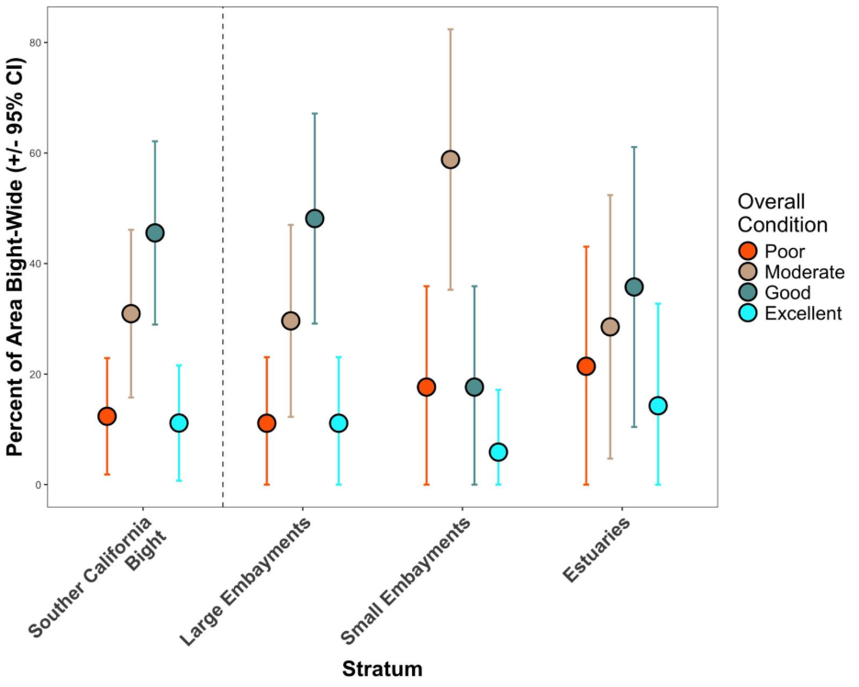
Figure 4. Percent area estimates (with 95% confidence intervals) of overall eelgrass condition score by stratum. The points represent area estimates derived using the Horvitz-Thompson estimator and the error bars represent the stratum-based confidence intervals.

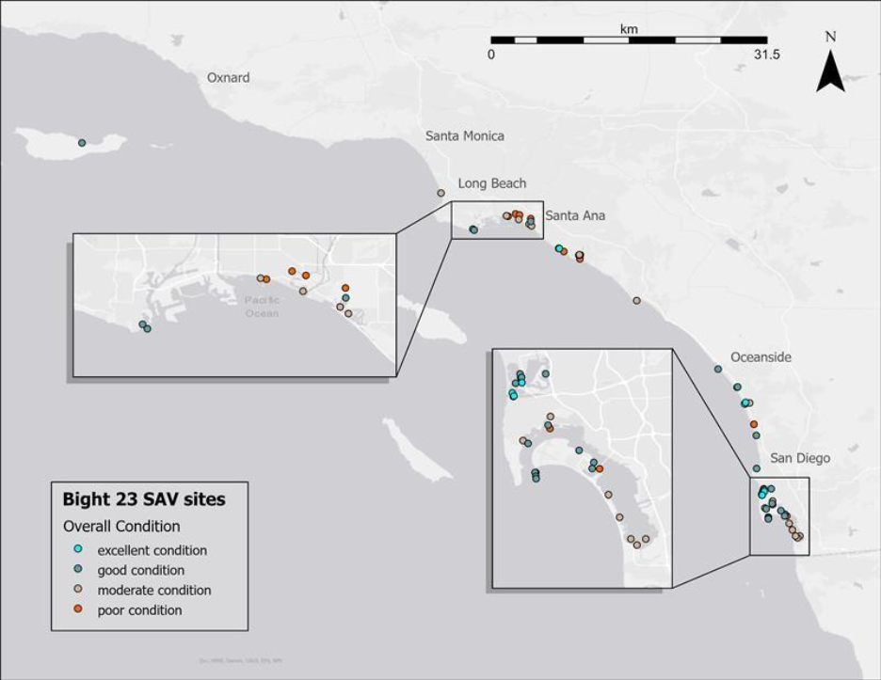Figure 5. Geographic distribution of overall eelgrass condition throughout the Southern California Bight. The legend shows point color corresponding to overall eelgrass condition categories.

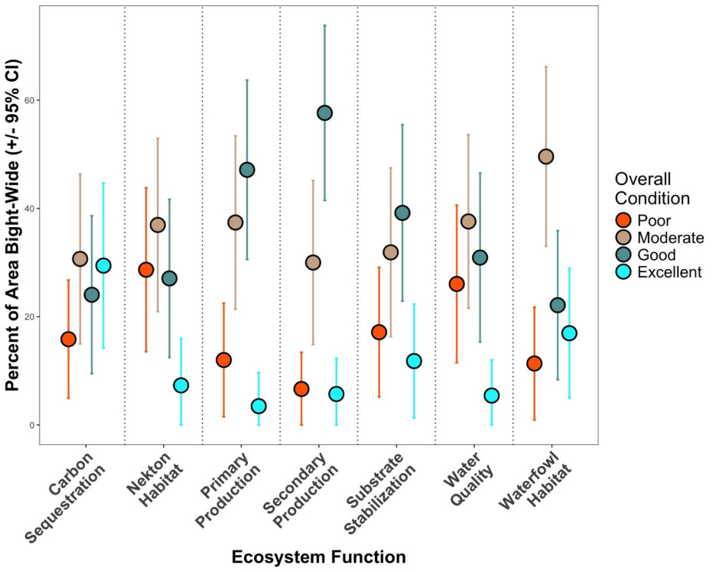
Figure 6. Percent area estimates (with 95% confidence intervals) of the seven ecosystem function scores in each of the four condition categories. Points represent area estimates derived using the Horvitz-Thompson estimator, and error bars represent stratum-based confidence intervals.

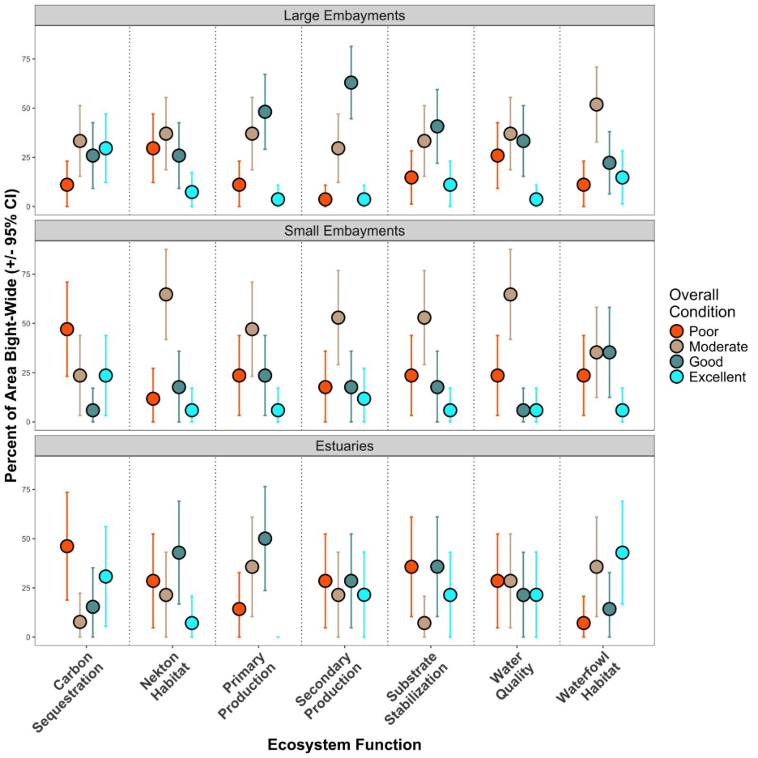
Figure 7. Percent area estimates (with 95% confidence intervals) of each of the seven ecosystem function scores in each of the four condition categories. Points represent area estimates derived from the Horvitz-Thomspon estimator and error bars represent stratum-based confidence intervals.

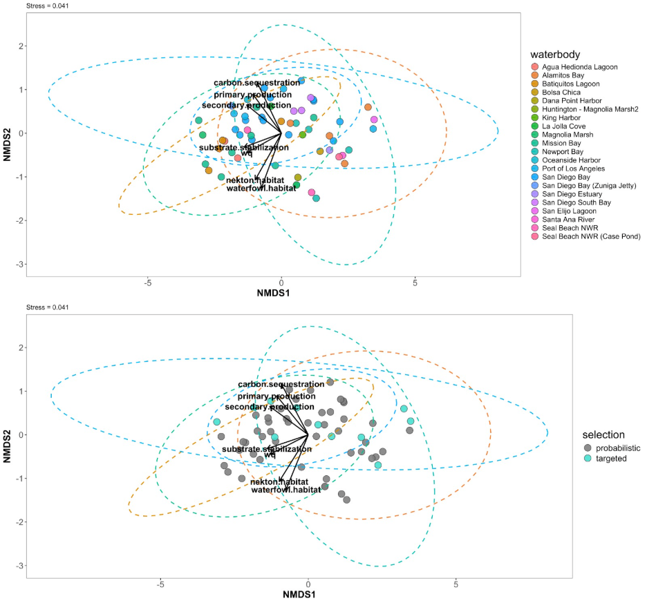
Figure 8. Two-dimensional non-metric multidimensional scaling (nMDS) ordination of ecosystem function scores at each site by (top) waterbody, and (bottom) site selection. Ellipses represent 95% of the data for each waterbody. Ecosystem function plotted as environmental factor correlations from envfit(). Stress = 0.041.

=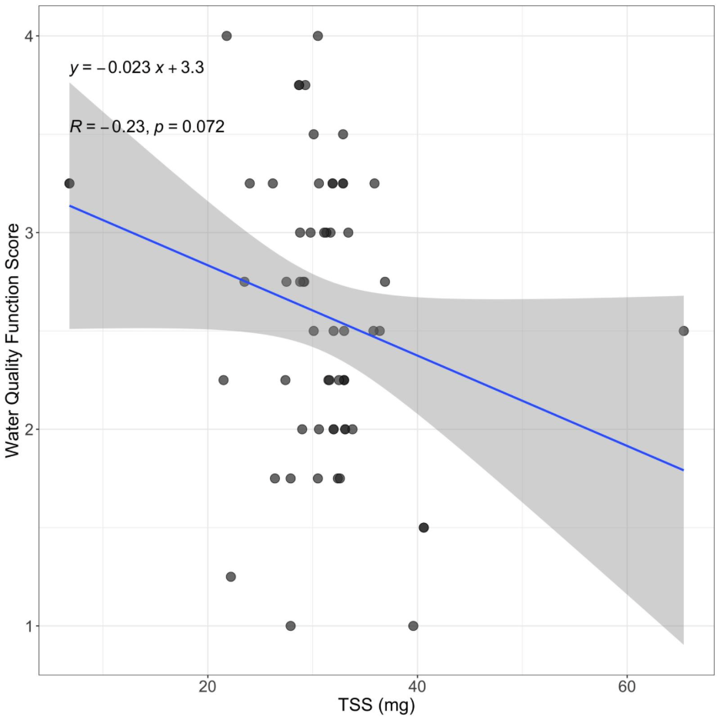
Figure 9. Total Suspended Solids (TSS) in milligrams per 500 mL water versus water quality ecosystem function scores. TSS data was not available for all sites. Geom_smooth() represents the 95% confidence interval for this observed relationship.
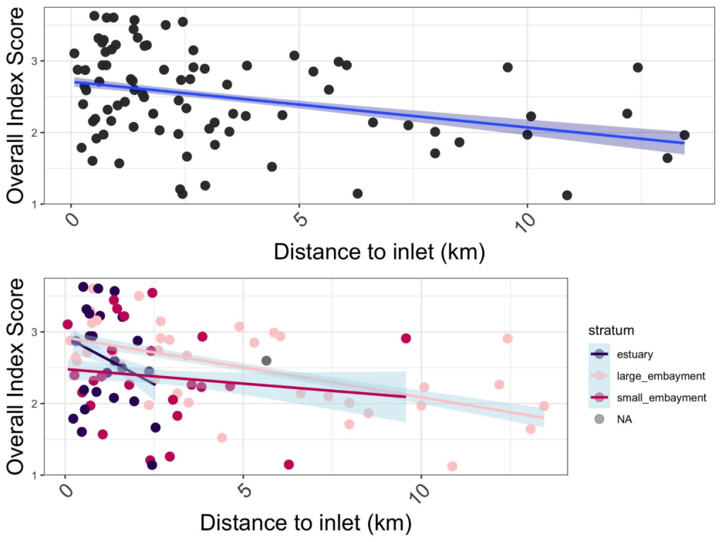
Figure 10. Overall eelgrass index scores with distance to inlet (km). (Top) All sites with a negative and significant (p = 3.25 x 10⁻⁴) relationship (Overall Index Score = 2.74 - 0.069 *(Distance-to-inlet). (Bottom) All sites colored by strata. No significant relationships in linear regression models.
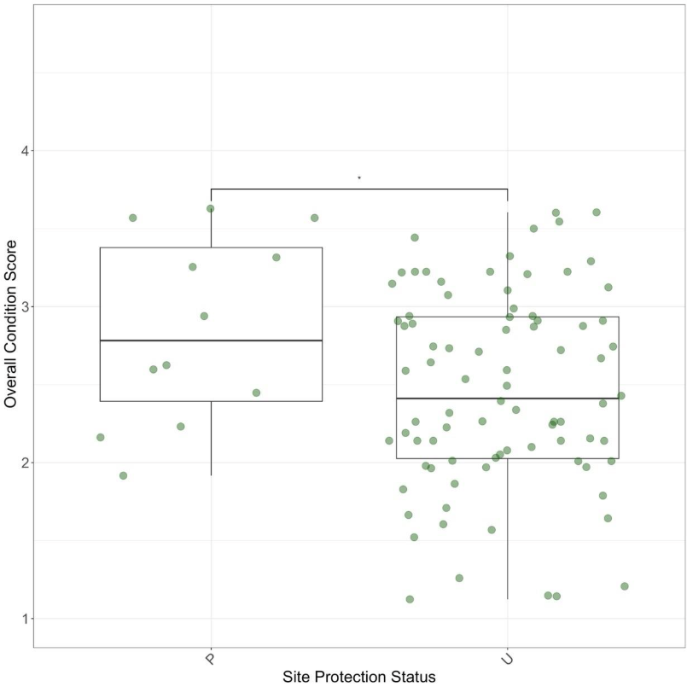
Figure 11. Overall eelgrass condition scores by nominal site protection status. P = “protected”, “U” = unprotected. Protected sites include areas within designated Marine Protected Areas (no take, limited take, State Marine Reserves, State Marine Conservation Areas). Unprotected sites are areas that are not protected from take in some way, including National Wildlife Refuges. Points were jittered on the x-axis. Significant difference between groups via Wilcox test (p = 0.049).
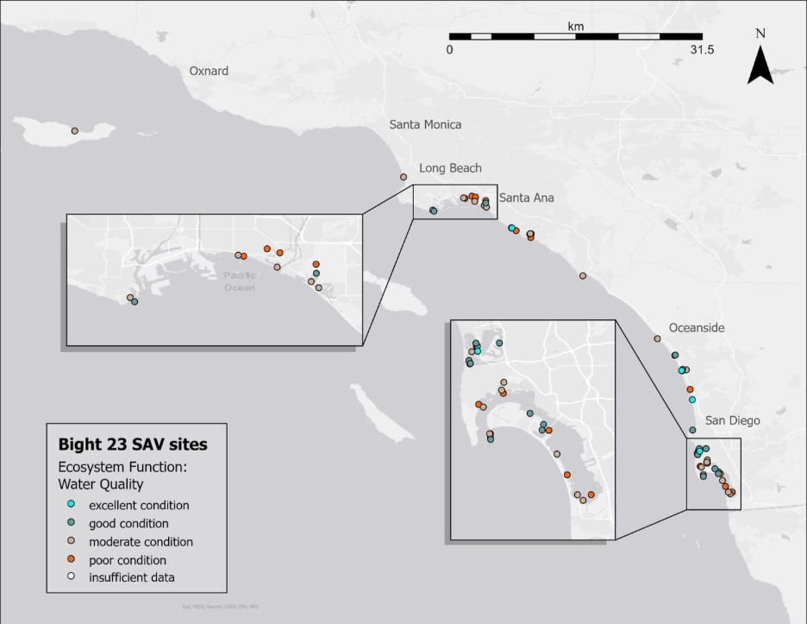
Figure 12. Geographic distribution of estimated water quality ecosystem function throughout the Southern California Bight. The legend shows point color corresponding to water quality condition categories.

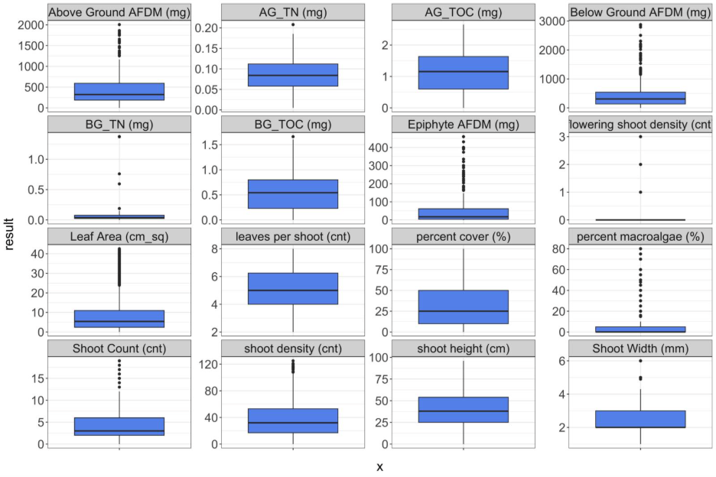
Figure 13. Eelgrass structural metrics from the Southern California Bight in 2023-2024. The midline of each box represents the median value for each structural metric. The upper and lower bounds of the box represent the interquartile range (IQR, 25th and 75% percentiles of data), whiskers are 1.5 x IQR for each metric, and anything outside that range is plotted as an outlier point.
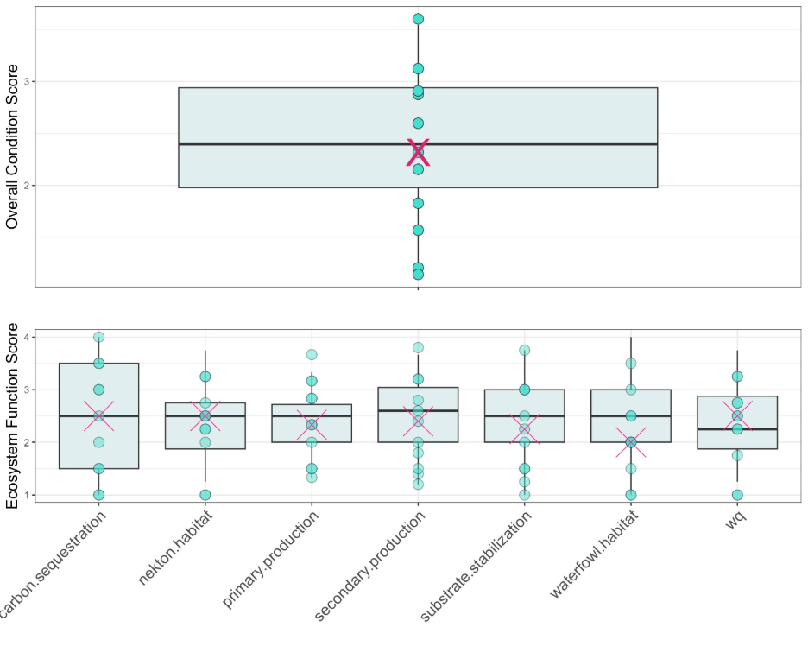
Figure 14. Top: Boxplots of probabilistic sites’ overall condition scores, with targeted sites as points and the median of overall condition score of targeted sites as a pink mark. Bottom: Boxplots of probabilistic sites’ ecosystem functions scores, with targeted sites as points and the median of each ecosystem function score of targeted sites as a pink mark. The midline of each box represents the median score of probabilistic sites, the IQR is the 25th and 75th percentiles of score data, and the whiskers are 1.5 x IQR.

- Discussion
This survey represents one of the first regional -scale assessments of eelgrass condition in Southern California Bight. The results indicated that more than 55% of the region’s eelgrass area were in either Excellent or Good Condition from the perspective of supporting key ecological functions. The pattern amongst the three strata we structured the survey around showed that eelgrass condition in small embayments were in slightly worse condition than it was in large embayments of estuaries. Nearly half of the eelgrass bed area surveyed in 2024 across the Southern California Bight was in Good Condition, followed by nearly a third of the remaining eelgrass bed area in Moderate Condition. Furthermore, there were estimated differences in overall eelgrass condition across strata. Within our spatially-explicit design, whereby an equal number of sites were chosen from each stratum, we extend the observation that the majority of eelgrass bed area in small embayments are in Moderate Condition, whereas the highest percentage of area in estuaries and large embayments are in Good Condition.
This first Bight regional survey of eelgrass also resulted in a series of standards and protocols that are publicly available and backed by a community of practice. Successful field intercalibration took place, leading to high-quality data collection conducted by multiple groups over a large geographic range. Through the process of data compilation and error tracking yielded understanding of where errors arise in data collection and how to prevent them. Lastly, group field debriefs gave our community of practice ideas for future protocol improvement and the actions needed to ensure that protocol changes do not impact data quality.

Comparison to bight sediment quality patterns?

All ports and harbors (Port of Los Angeles, King Harbor, Oceanside Harbor, Dana Point Harbor) were considered small embayments, which may account for the observed contrast in overall eelgrass condition in the small embayment stratum. Ports and harbors may be influenced more acutely by boating activity, wave exposure, pollution, invasive species introduction, and human recreation than other waterbody types, which can all be deleterious to eelgrass condition (Fonseca & Bell 1998, Hansen & Reidenbach 2012). Eelgrass in these settings may also be susceptible to potential stressors due to their proximity to the densely populated Southern California coastline (Shelton et al. 2016; Mehinto et al. 2025). For example, one site in the Port of Los Angeles (B23-SAV-015) had 65.4 mg/L TSS, which was the highest TSS value Bight-wide. Sedimentation of the water column in a known stressor to eelgrass, limiting light available to the plant itself, and can be exacerbated by human activities such as boating.

Another example of potential stress is Caulerpa outbreaks that have been documented and treated since October 2023 in South San Diego Bay. Eelgrass beds adjacent to areas impacted by this invasive macroalgae were included in this survey. Eelgrass beds were estimated in Poor to Moderate overall condition in this area, scoring notably lower in Nekton Habitat and Water Quality ecosystem functions, which may both be affected by Caulerpa outbreaks.

Among the utilities of the eelgrass index is the ability to deconstruct the tool into its corresponding ecosystem functions, and even the structural metrics included in the calculation of those functions, to investigate how unexpectedly low or high scores arise. For example, potential explanations for the discrepancy observed in overall eelgrass condition between small embayments and other two strata can be investigated in this way. In small embayments, Carbon Sequestration had the largest amount of area in Poor Condition, with most area in the other six ecosystem functions estimated in Moderate Condition. Aboveground and Belowground biomass were averaged to produce the Carbon Sequestration ecosystem function score, and in the case of small embayments, belowground biomass was slightly (though not statistically significantly) less than in large embayments (Figure A2). Estuaries showed the same pattern of estimated Carbon Sequestration in Poor Condition. If a manager was interested in boosting Carbon Sequestration ecosystem function estimated by this tool, and therefore overall eelgrass condition, creating environmental settings that facilitate belowground storage of carbon in eelgrass could be a starting point.

On the other hand, a manager could also use this same approach to investigate the patterns in high scoring sites. For example, estuaries had their largest area estimated in Excellent Condition for Waterfowl Habitat. This observation is supported by a large body of estuarine literature, as well as a growing repository of citizen science data, emphasizing the importance of estuaries as bird habitat (Masto et al. 2025; Whitcraft et al. 2025). Sites with long shoot heights and large shoot densities receive high Waterfowl Habitat ecosystem function scores. While shoot height was comparable across strata, shoot density was higher (though not statistically significantly) in estuaries than in the other two strata (Figure A1). The reason for high Waterfowl Habitat scores based on this tool comes down to estuaries having the right conditions for dense beds of eelgrass. The investigation of high scoring sites presents the opportunity to validate this novel eelgrass index by drawing direct comparisons between shoot density, Waterfowl Habitat ecosystem function scores, and bird activities (foraging, mating, migration). Leveraging available and concurrent estuary data from California monitoring programs such as EMPA (O'Connor et al. 2025; Whitcraft et al. 2025), and connecting it with eelgrass data presented here, could be a starting point for eelgrass index validation around Waterfowl Habitat, Water Quality, Nekton Habitat, and Secondary Production ecosystem functions (O’Connor et al 2025).

A useful index from the standpoint of measuring habitat function loss in eelgrass is one that is responsive to eelgrass stressors (pollution, light limitation, disease, destructive activities), but is not sensitive to natural gradients (depth) (Strong et al 2014; Mazor et al. 2016). However, some relationships between index scores and predictor variables (eutrophication, protection status, distance to inlet) are expected to be more complex. Chlorophyll a (ug/L) and TSS (mg/L) were used to explore responsiveness of the eelgrass index to these potential stressors. Likewise, distance to inlet (as-the-fish-swims), central depth (Mean High Water adjusted), and nominal site protection status (MPA vs. non-MPA) were also used to explore index response to natural gradients/potential indicators of good ecosystem health. For example, water column chlorophyll a and TSS can both be indicators of eutrophication, which can harm eelgrass through macroalgal overgrowth and light limitation (negative), but may also facilitate growth of eelgrass itself (positive).

The dual nature of these indicators on both the environmental setting as well as the plant allow understanding of how this index responds to a complex environment, but is not a complete evaluation of index performance. Likewise, distance to inlet may be an indirect measurement of pollution and environmental stability, with beds closest to the inlet further from sources of pollution and under stable marine influence, which could signify low stress conditions for eelgrass (Shelton et al. 2016). There is a negative relationship between index scores and distance to inlet, with increasing distance to inlet (further inland sites) scoring lower than sites close to the inlet in large embayments only. No such relationship was observed in either estuary nor small embayment strata. This is likely due to the smaller size of waterbodies the latter two strata, with distance to inlet capped well below 10 km in all cases. More information regarding complex estuarine chemistry and circulation is needed to tease out the relationship between site location within a body of water and its condition.

Site protection status may also have a complex relationship with eelgrass health. Certain protections of a site within a Marine Protected Area may facilitate better eelgrass condition by creating conditions that reduce ecological impact from human activities (Gleason et al. 2013). On the other hand, locations of Marine Protected Areas are chosen based on many different criteria and objectives from a diverse community of interested parties (Gleason et al. 2013). Protections may be enacted to conserve an already ecologically healthy area, or they could be put in place to help an impacted area recover. The relationship between protection status and eelgrass index score may be partially explained by protections facilitating healthy eelgrass condition, but it also could be equally explained by management selection of already healthy sites. Even so, there was a significant difference in eelgrass index scores between protected and unprotected sites, with higher scores estimated at protected sites. While there is not a clear reason for this observation, the responsiveness of the eelgrass index to site protection status indicates a level of effectiveness for management use.

The results from this study are the first practical application of the index tool developed in Gillett et al. 2026, and of the assessment framework proposed by McCune et al. 2020, and characterize the overall condition of eelgrass throughout the Southern California Bight. This tool is uniquely positioned to allow management and regulatory communities to better understand eelgrass condition from the perspective of supported ecosystem functions. Due to the ephemeral spatial coverage of eelgrass over time, as reported by several previous inventories (Merkel & Associates Inc. 2014b; Merkel & Associates Inc. 2024), structural eelgrass data through a longer time period is recommended to refine the existing tool, as data from only one season (late summer/fall 2024) was used to develop the tool.

The monitoring approach and structure-function concepts underpinning the index tool should translate to other regions, regardless of the dominant seagrass species. In some cases, implementation in other habitats may benefit from a revision of the conceptual model, to ensure that all ecosystem functions are supported by the species of interest. For example, some smaller species may not have as comparable ecosystem functions as larger species (Nordlund et al. 2016). However, the existing index here is generated using a range of structural metrics measured in Southern California, and should therefore be used with caution in other locations that have different species or environmental conditions. For example, The North Pacific US Coast, while dominated by Zostera marina, has a larger proportion of intertidal eelgrass than in Southern California, which may impact its morphology and therefore structural metrics such as shoot height, leaf area, above and belowground biomass ( Sherman & DeBruyckere 2018). Additionally, other environmental changes that occur across a latitudinal gradient (water and air temperature, PAR, exposure, coastal morphology) may also impact the morphology of the seagrass through phenotypic plasticity of the plant itself (Cabello-Pasini et al. 2003; Jarvis et al. 2012; Clausen et al. 2014). Applying this index framework to other locations with different species of seagrass appropriately requires adjustment of structural metrics to the species or group of species present.

This survey took place concurrently and over the same geographic range as the Gillett et al. 2026 study, and was the first application of the index tool proposed. While the results of both studies are comparable in most ways, there are a few points of notable contrast. For example, the total area of the Bight estimated in each condition category followed a similar pattern in both studies: the most amount of area was in the second highest condition category. However, the percent area of the Bight in the lowest overall condition category was 12% in this study, but only 3% in Gillett et al. 2026. There was notably no area in the lowest condition category in large embayments versus 11% estimated in this study. There Gillett et al. 2026 study found that there were no major differences in area in each condition category across strata. This study identified a that the small embayments had overall worse condition that the other strata. This discrepancy may be a function of more coverage of small embayments in this habitat, since six out of eleven targeted sites were in small embayments.

It is worth mentioning that the condition category naming convention is different between the two studies, although the thresholds for assigning condition was identical. The Gillett et al. study proposed four condition categories: Bad, Poor, Moderate, and Good, whereas this study proposes: Poor, Moderate, Good, Excellent. The subjectivity of the naming convention highlights a future need to contextualize the index tool within the ecology of the system by either delineating true “reference” sites, and/or adding in quantitative thresholds of structural metrics that produce a known effect on individual ecological functions. For example, if Below Ground biomass falls below a certain amount for any given bed, such that carbon sequestration rates are equal to carbon emissions of the same bed, we might incorporate that knowledge into the index tool by changing how Carbon Sequestration Ecosystem Function is calculated. In other words, validation studies are needed to fine-tune this tool to discriminate between condition categories that have more specific ecological meanings.

- Conclusions
- Most of the Bight-wide area of eelgrass is in either Good or Moderate Condition
- Estuaries and large embayments have slightly better overall eelgrass condition than small embayments
- We have developed a novel, quantitative tool to score Zostera marina condition through the perspective of supported ecosystem functions across the Southern California Bight
- Several environmental features helped us understand how eelgrass scores and estimated ecosystem functions relate to areas with complex coastal chemistry, protection, and circulation.

- Recommendations
- Please add/describe any other recommendations you may have based on our results!
- The survey should be repeated as part of the 2028 Southern California Bight Regional Monitoring Program to begin characterizing the spatial and temporal variability in eelgrass condition
- Future eelgrass assessment surveys should be expanded to explicitly include coastal open water Zostera pacifica (broad leaf eelgrass) beds
- An analogous structure-function assessment framework should be developed for other important species of SAV in California (e.g., surf grass (Phyllospadix spp) or widgeon grass (Ruppia maritima))
- Eelgrass condition scores should be mapped directly to achievement of Estuarine beneficial uses / develop a way to contextualize condition results to be used in evaluating success under the CEMP
- Conduct validation studies that contextualize ecosystem function estimates to actual rate processes, such as linking the Carbon Sequestration Ecosystem Function to carbon sequestration rates.

- Literature Cited
Anderson, L. W. J. California’s Reaction to Caulerpa Taxifolia: A Model for Invasive Species Rapid Response*. Biol Invasions 2005, 7 (6), 1003–1016. https://doi.org/10.1007/s10530-004-3123-z.
Bernstein B, Merkel K, Chesney B, Sutula M (2011) Recommendations for a Southern California Regional Eelgrass Monitoring Program - SCCWRP Technical Report 632. Costa Mesa, CA.
Blake, R. E.; Duffy, J. E. Influence of Environmental Stressors and Grazer Immigration on Ecosystem Properties of an Experimental Eelgrass Community. Journal of Experimental Marine Biology and Ecology 2016, 480, 45–53. https://doi.org/10.1016/j.jembe.2016.03.007.

Cabello-Pasini A, Muniz-Salazar R, Ward DH (2003) Annual variations of biomass and photosynthesis in Zostera marina at its southern end of distribution in the North Pacific. Aquat Bot 76: 31−47
Cimon, S.; Deslauriers, A.; Cusson, M. Multiple Stressors and Disturbance Effects on Eelgrass and Epifaunal Macroinvertebrate Assemblage Structure. Mar. Ecol. Prog. Ser. 2021, 657, 93–108. https://doi.org/10.3354/meps13546.

Clausen, K.; Krause-Jensen, D.; Olesen, B.; Marbà, N. Seasonality of Eelgrass Biomass across Gradients in Temperature and Latitude. Mar. Ecol. Prog. Ser. 2014, 506, 71–85. https://doi.org/10.3354/meps10800.

Doughty CL, Cavanaugh KC, Ambrose RF, Stein ED (2019) Evaluating regional resiliency of coastal wetlands to sea level rise through hypsometry-based modeling. Glob Chang Biol 25:78–92.
Dumelle M, Kincaid T, Olsen AR, Weber M (2023). spsurvey: Spatial Sampling Design and Analysis in R. Journal of Statistical Software, 105(3), 1-29. doi:10.18637/jss.v105.i03
Friess, D. A.; Shribman, Z. I.; Stankovic, M.; Iram, N.; Baustian, M. M.; Ewers Lewis, C. J. Restoring Blue Carbon Ecosystems. Camb. prisms Coast. futures 2024, 2, e9. https://doi.org/10.1017/cft.2024.9.

Gillett, D.J., McCune, K., and Stein, E.D. 2018a. Development of a Monitoring and Assessment Framework for Submerged Aquatic Vegetation (SAV) Technical Report #1 – Monitoring and Assessment Framework. 13p. Southern California Coastal Water Research Project, Costa Mesa, CA.
Gleason, M.; Fox, E.; Ashcraft, S.; Vasques, J.; Whiteman, E.; Serpa, P.; Saarman, E.; Caldwell, M.; Frimodig, A.; Miller-Henson, M.; Kirlin, J.; Ota, B.; Pope, E.; Weber, M.; Wiseman, K. Designing a Network of Marine Protected Areas in California: Achievements, Costs, Lessons Learned, and Challenges Ahead. Ocean & Coastal Management 2013, 74, 90–101. https://doi.org/10.1016/j.ocecoaman.2012.08.013

Hansen, J.; Reidenbach, M. Wave and Tidally Driven Flows in Eelgrass Beds and Their Effect on Sediment Suspension. Mar. Ecol. Prog. Ser. 2012, 448, 271–287. https://doi.org/10.3354/meps09225.

Heck KL Jr, Hays G, Orth RJ (2003) Critical evaluation of the nursery role hypothesis for seagrass meadows. Mar Ecol Prog Ser 253:123−136
Hughes, B. B.; Lummis, S. C.; Anderson, S. C.; Kroeker, K. J. Unexpected Resilience of a Seagrass System Exposed to Global Stressors. Global Change Biology 2018, 24 (1), 224–234. https://doi.org/10.1111/gcb.13854
Jarvis JC, Moore KA, Kenworthy WJ (2012) Characterization and ecological implication of eelgrass life history strategies near the species’ southern limit in the western North Atlantic. Mar Ecol Prog Ser 444: 43−56
Masto, N. M.; Dunham, K. D.; Brasher, M. G.; Ringelman, K. M.; Osborn, J. M.; Avers, B.; Bidrowski, T.; Ervin, M.; Jones, O. E.; Loges, B. W.; McClain, D.; Phelps, W. A.; Vanausdall, R.; Lancaster, J. D.; Robinson, O. J. Citizen Science Generates Reliable Migration Chronologies to Supplement Professional Surveys for Waterfowl Habitat Management. Ornithological Applications 2025, 127 (3), duaf030. https://doi.org/10.1093/ornithapp/duaf030.

Mazor, R. D.; Rehn, A. C.; Ode, P. R.; Engeln, M.; Schiff, K. C.; Stein, E. D.; Gillett, D. J.; Herbst, D. B.; Hawkins, C. P. Bioassessment in Complex Environments: Designing an Index for Consistent Meaning in Different Settings. Freshwater Science 2016, 35 (1), 249–271. https://doi.org/10.1086/684130.

Mehino A, Greenstein D, Schiff K. 2025. Southern California Bight 2023 Regional Monitoring Program: Volume I. Sediment Toxicity Technical Report 1433. Costa Mesa, CA.
Merkel & Associates Inc. (2014a) 2014 San Diego Bay Eelgrass Inventory.

Merkel & Associates Inc. (2014b) Southern California Bight Regional Eelgrass Surveys.
Merkel & Associates Inc. (2024) 2023 San Diego Bay Eelgrass Inventory Update. San Diego, CA. NOAA/ National Marine Fisheries Service West Coast Region Protected Resources Division, San Diego, CA.
NOAA National Marine Fisheries Service (2014) California Eelgrass Mitigation Policy and Implementing Guidelines.
Mtwana Nordlund, L.; Koch, E. W.; Barbier, E. B.; Creed, J. C. Seagrass Ecosystem Services and Their Variability across Genera and Geographical Regions. PLoS ONE 2016, 11 (10), e0163091. https://doi.org/10.1371/journal.pone.0163091
O’Connor K, Fulkerson B, Walker J, Stein E, Whitcraft CR, Huckeba J (2025) Estuary Marine Protected Area Fall 2023 Data Analysis Report SCCWRP Technical Report #1430. Costa Mesa, CA.
Oksanen J, Simpson G, Blanchet F, Kindt R, Legendre P, Minchin P, O'Hara R, Solymos P, Stevens M, Szoecs E, Wagner H, Barbour M, Bedward M, Bolker B, Borcard D, Borman T, Carvalho G, Chirico M, DeCaceres M, Durand S, Evangelista H, FitzJohn R, Friendly M, Furneaux B, Hannigan G, Hill M, Lahti L,Martino C, McGlinn D, Ouellette M, Ribeiro Cunha E, Smith T, Stier A, Ter Braak C, Weedon J (2025). vegan: Community Ecology Package. doi:10.32614/CRAN.package.vegan
Ruiz-Frau, A.; Gelcich, S.; Hendriks, I. E.; Duarte, C. M.; Marbà, N. Current State of Seagrass Ecosystem Services: Research and Policy Integration. Ocean & Coastal Management 2017, 149, 107–115. https://doi.org/10.1016/j.ocecoaman.2017.10.004.

Shelton, A. O.; Francis, T. B.; Feist, B. E.; Williams, G. D.; Lindquist, A.; Levin, P. S. Forty Years of Seagrass Population Stability and Resilience in an Urbanizing Estuary. Journal of Ecology 2017, 105 (2), 458–470. https://doi.org/10.1111/1365-2745.12682.

Sherman K, DeBruyckere LA (2018) Eelgrass Habitats on the U.S. West Coast. State of the Knowledge of Eelgrass Ecosystem Services and Eelgrass Extent. A publication prepared by the Pacific Marine and Estuarine Fish Habitat Partnership. 67.
Simenstad CA. 1994. Faunal Association and Ecological Interactions in Seagrass Communities of the Pacific Northwest Coast. 11-18 in: S. Wyllie-Echeverria, Olso AM, and Hershman J (eds), Seagrass Science and Policy in the Pacific Northwest. EPA 910/R-94-004. Environmental Protection Agency. Seattle, WA.
Strong, J. A.; Andonegi, E.; Bizsel, K. C.; Danovaro, R.; Elliott, M.; Franco, A.; Garces, E.; Little, S.; Mazik, K.; Moncheva, S.; Papadopoulou, N.; Patrício, J.; Queirós, A. M.; Smith, C.; Stefanova, K.; Solaun, O. Marine Biodiversity and Ecosystem Function Relationships: The Potential for Practical Monitoring Applications. Estuarine, Coastal and Shelf Science 2015, 161, 46–64. https://doi.org/10.1016/j.ecss.2015.04.008.

USEPA (1971). Method 160.2, Residue, Non-Filterable (Gravimetric, Dried at 103-105°C). U.S. Environmental Protection Agency, Washington, D.C.

Welschmeyer NA. Fluorometric analysis of chlorophyll a in the presence of chlorophyll b and pheopigments. Limnol Oceanogr. 1994;39: 1985–1992.

Whiftcraft C, Stein E, Walker J, Spies B, Dagit R, Ambrose R, Johnston K, Tupitza J, Le Compte Santiago A. 2025. Santa Monica Bay National Estuary Program State of the Bay Technical Chapter: Coastal Wetlands. Southern California Coastal Water Research Project. Technical Report #1460. Costa Mesa, CA.

Appendix A – Eelgrass structural metrics

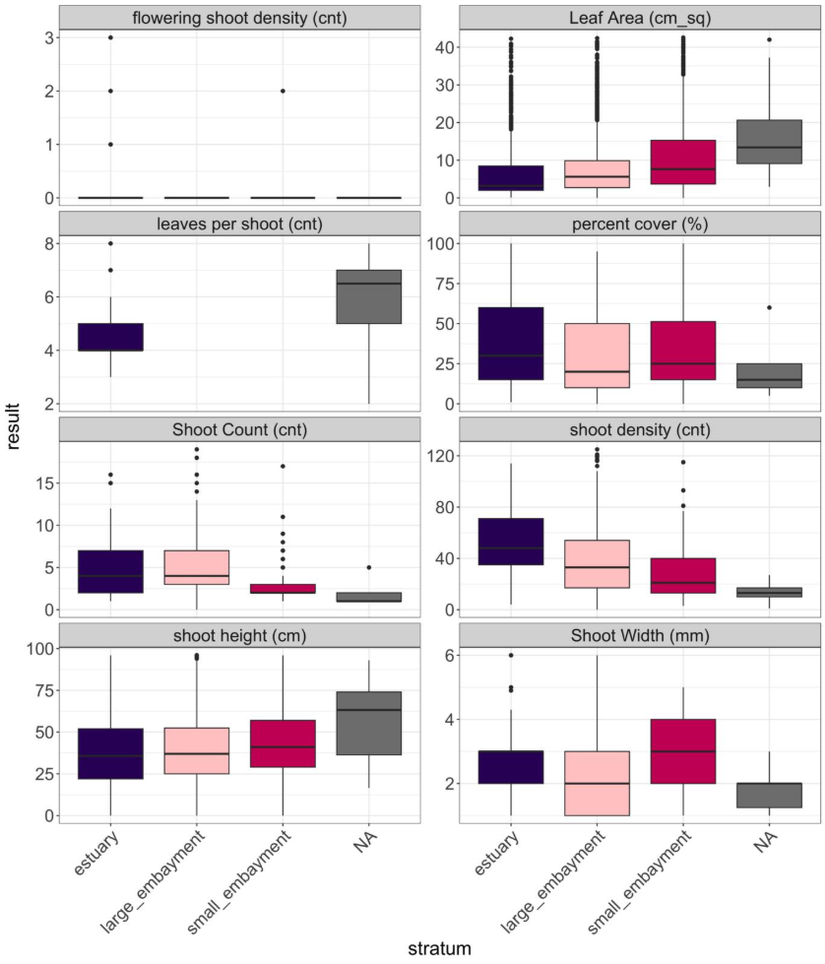
Figure A1. Eelgrass structural metric data by stratum – part 1.
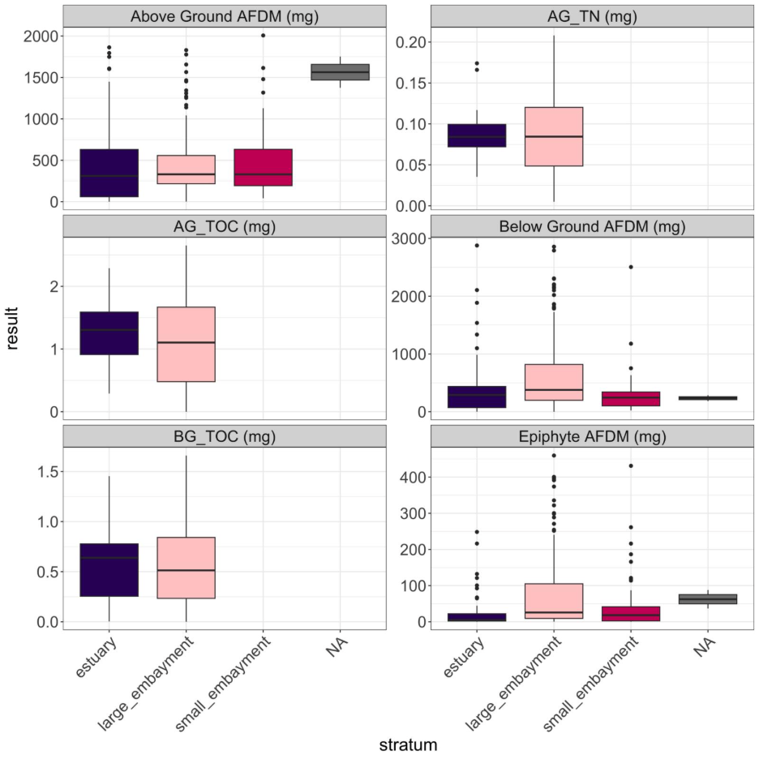
Figure A2. Eelgrass structural metric data by stratum – part 2.

Appendix B – Eelgrass index and function scores

Table B1. Site by site ecosystem function scores and overall eelgrass condition scores.
Table B2. Overall eelgrass condition scores by waterbody
waterbody | mean | sd | min | max | range | Overall condition
Agua Hedionda Lagoon | 3.082 | 0.147 | 2.94 | 3.22 | 0.28 | good condition
Alamitos Bay | 1.731 | 0.412 | 1.21 | 2.32 | 1.11 | poor condition
Batiquitos Lagoon | 2.989 | 0.35 | 2.45 | 3.32 | 0.87 | good condition
Bolsa Chica | 1.917 | 0 | 1.92 | 1.92 | 0 | moderate condition
Dana Point Harbor | 2.243 | 0 | 2.24 | 2.24 | 0 | moderate condition
Huntington - Magnolia Marsh | 2.262 | 0 | 2.26 | 2.26 | 0 | moderate condition
King Harbor | 2.155 | 0 | 2.15 | 2.15 | 0 | moderate condition
La Jolla Cove | 2.598 | 0 | 2.6 | 2.6 | 0 | good condition
Magnolia Marsh | 2.904 | 0.666 | 2.26 | 3.55 | 1.29 | good condition
Mission Bay | 2.96 | 0.51 | 1.98 | 3.6 | 1.62 | good condition
Newport Bay | 1.944 | 0.266 | 1.52 | 2.23 | 0.71 | moderate condition
Oceanside Harbor | 2.91 | 0 | 2.91 | 2.91 | 0 | good condition
Port of Los Angeles | 2.395 | 0.78 | 1.15 | 3.1 | 1.95 | moderate condition
San Diego Bay | 2.462 | 0.48 | 1.64 | 3.07 | 1.43 | moderate condition
San Diego Bay (Zuniga Jetty) | 3.124 | 0 | 3.12 | 3.12 | 0 | good condition
San Diego Estuary | 1.788 | 0 | 1.79 | 1.79 | 0 | moderate condition
San Diego South Bay | 2.138 | 0.107 | 2.01 | 2.26 | 0.25 | moderate condition
San Dieguito Lagoon | 3.208 | 0 | 3.21 | 3.21 | 0 | good condition
San Elijo Lagoon | 1.143 | 0 | 1.14 | 1.14 | 0 | poor condition
Santa Ana River | 1.605 | 0 | 1.6 | 1.6 | 0 | poor condition
Santa Cruz Island | 2.625 | 0 | 2.62 | 2.62 | 0 | good condition
Seal Beach NWR | 2.477 | 0.414 | 2.08 | 2.88 | 0.8 | moderate condition
Seal Beach NWR (Case Pond) | 1.664 | 0 | 1.66 | 1.66 | 0 | poor condition

Table B3. Percent area-weighted ecosystem function scores by stratum, including upper and lower 95% confidence intervals.
Ecosystem Function | Stratum | Condition | Percent Area Estimate | Lower 95% CI | Upper 95% CI
substrate stabilization | estuary | Poor | 35.69 | 10.39 | 60.98
substrate stabilization | estuary | Moderate | 7.14 | 0 | 20.73
substrate stabilization | estuary | Good | 35.76 | 10.44 | 61.08
substrate stabilization | estuary | Excellent | 21.41 | 0 | 43.07
substrate stabilization | estuary | Total | 100 | 100 | 100
substrate stabilization | large_embayment | Poor | 14.81 | 1.3 | 28.33
substrate stabilization | large_embayment | Moderate | 33.33 | 15.4 | 51.27
substrate stabilization | large_embayment | Good | 40.74 | 22.05 | 59.43
substrate stabilization | large_embayment | Excellent | 11.11 | 0 | 23.07
substrate stabilization | large_embayment | Total | 100 | 100 | 100
substrate stabilization | small_embayment | Poor | 23.53 | 3.22 | 43.84
substrate stabilization | small_embayment | Moderate | 52.94 | 29.04 | 76.84
substrate stabilization | small_embayment | Good | 17.65 | 0 | 35.9
substrate stabilization | small_embayment | Excellent | 5.88 | 0 | 17.15
substrate stabilization | small_embayment | Total | 100 | 100 | 100
carbon sequestration | estuary | Poor | 46.15 | 18.83 | 73.48
carbon sequestration | estuary | Moderate | 7.69 | 0 | 22.3
carbon sequestration | estuary | Good | 15.38 | 0 | 35.16
carbon sequestration | estuary | Excellent | 30.77 | 5.47 | 56.07
carbon sequestration | estuary | Total | 100 | 100 | 100
carbon sequestration | large_embayment | Poor | 11.11 | 0 | 23.07
carbon sequestration | large_embayment | Moderate | 33.33 | 15.4 | 51.27
carbon sequestration | large_embayment | Good | 25.93 | 9.25 | 42.6
carbon sequestration | large_embayment | Excellent | 29.63 | 12.25 | 47
carbon sequestration | large_embayment | Total | 100 | 100 | 100
carbon sequestration | small_embayment | Poor | 47.06 | 23.15 | 70.96
carbon sequestration | small_embayment | Moderate | 23.53 | 3.21 | 43.85
carbon sequestration | small_embayment | Good | 5.88 | 0 | 17.15
carbon sequestration | small_embayment | Excellent | 23.53 | 3.21 | 43.85
carbon sequestration | small_embayment | Total | 100 | 100 | 100
primary production | estuary | Poor | 14.27 | 0 | 32.74
primary production | estuary | Moderate | 35.69 | 10.39 | 60.98
primary production | estuary | Good | 50.04 | 23.63 | 76.44
primary production | estuary | Excellent | 0 | 0 | 0
primary production | estuary | Total | 100 | 100 | 100
primary production | large_embayment | Poor | 11.11 | 0 | 23.07
primary production | large_embayment | Moderate | 37.04 | 18.67 | 55.41
primary production | large_embayment | Good | 48.15 | 29.14 | 67.16
primary production | large_embayment | Excellent | 3.7 | 0 | 10.89
primary production | large_embayment | Total | 100 | 100 | 100
primary production | small_embayment | Poor | 23.53 | 3.22 | 43.84
primary production | small_embayment | Moderate | 47.06 | 23.16 | 70.96
primary production | small_embayment | Good | 23.53 | 3.22 | 43.84
primary production | small_embayment | Excellent | 5.88 | 0 | 17.15
primary production | small_embayment | Total | 100 | 100 | 100
secondary production | estuary | Poor | 28.55 | 4.7 | 52.4
secondary production | estuary | Moderate | 21.41 | 0 | 43.07
secondary production | estuary | Good | 28.55 | 4.7 | 52.4
secondary production | estuary | Excellent | 21.49 | 0 | 43.2
secondary production | estuary | Total | 100 | 100 | 100
secondary production | large_embayment | Poor | 3.7 | 0 | 10.89
secondary production | large_embayment | Moderate | 29.63 | 12.26 | 47
secondary production | large_embayment | Good | 62.96 | 44.59 | 81.33
secondary production | large_embayment | Excellent | 3.7 | 0 | 10.89
secondary production | large_embayment | Total | 100 | 100 | 100
secondary production | small_embayment | Poor | 17.65 | 0 | 35.9
secondary production | small_embayment | Moderate | 52.94 | 29.04 | 76.84
secondary production | small_embayment | Good | 17.65 | 0 | 35.9
secondary production | small_embayment | Excellent | 11.76 | 0 | 27.19
secondary production | small_embayment | Total | 100 | 100 | 100
water quality | estuary | Poor | 28.55 | 4.7 | 52.4
water quality | estuary | Moderate | 28.55 | 4.7 | 52.4
water quality | estuary | Good | 21.41 | 0 | 43.07
water quality | estuary | Excellent | 21.49 | 0 | 43.2
water quality | estuary | Total | 100 | 100 | 100
water quality | large_embayment | Poor | 25.93 | 9.25 | 42.6
water quality | large_embayment | Moderate | 37.04 | 18.67 | 55.41
water quality | large_embayment | Good | 33.33 | 15.4 | 51.27
water quality | large_embayment | Excellent | 3.7 | 0 | 10.89
water quality | large_embayment | Total | 100 | 100 | 100
water quality | small_embayment | Poor | 23.53 | 3.22 | 43.84
water quality | small_embayment | Moderate | 64.71 | 41.82 | 87.59
water quality | small_embayment | Good | 5.88 | 0 | 17.15
water quality | small_embayment | Excellent | 5.88 | 0 | 17.15
water quality | small_embayment | Total | 100 | 100 | 100
nekton habitat | estuary | Poor | 28.55 | 4.7 | 52.4
nekton habitat | estuary | Moderate | 21.41 | 0 | 43.07
nekton habitat | estuary | Good | 42.9 | 16.76 | 69.04
nekton habitat | estuary | Excellent | 7.14 | 0 | 20.73
nekton habitat | estuary | Total | 100 | 100 | 100
nekton habitat | large_embayment | Poor | 29.63 | 12.26 | 47
nekton habitat | large_embayment | Moderate | 37.04 | 18.67 | 55.41
nekton habitat | large_embayment | Good | 25.93 | 9.25 | 42.6
nekton habitat | large_embayment | Excellent | 7.41 | 0 | 17.37
nekton habitat | large_embayment | Total | 100 | 100 | 100
nekton habitat | small_embayment | Poor | 11.76 | 0 | 27.19
nekton habitat | small_embayment | Moderate | 64.71 | 41.82 | 87.59
nekton habitat | small_embayment | Good | 17.65 | 0 | 35.9
nekton habitat | small_embayment | Excellent | 5.88 | 0 | 17.15
nekton habitat | small_embayment | Total | 100 | 100 | 100
waterfowl habitat | estuary | Poor | 7.14 | 0 | 20.73
waterfowl habitat | estuary | Moderate | 35.69 | 10.39 | 60.98
waterfowl habitat | estuary | Good | 14.27 | 0 | 32.74
waterfowl habitat | estuary | Excellent | 42.9 | 16.76 | 69.04
waterfowl habitat | estuary | Total | 100 | 100 | 100
waterfowl habitat | large_embayment | Poor | 11.11 | 0 | 23.07
waterfowl habitat | large_embayment | Moderate | 51.85 | 32.84 | 70.86
waterfowl habitat | large_embayment | Good | 22.22 | 6.41 | 38.04
waterfowl habitat | large_embayment | Excellent | 14.81 | 1.3 | 28.33
waterfowl habitat | large_embayment | Total | 100 | 100 | 100
waterfowl habitat | small_embayment | Poor | 23.53 | 3.22 | 43.84
waterfowl habitat | small_embayment | Moderate | 35.29 | 12.41 | 58.18
waterfowl habitat | small_embayment | Good | 35.29 | 12.41 | 58.18
waterfowl habitat | small_embayment | Excellent | 5.88 | 0 | 17.15
waterfowl habitat | small_embayment | Total | 100 | 100 | 100

Table B4. Percent area-weighted overall eelgrass condition scores by stratum, including upper and lower 95% confidence intervals.
Type | Stratum | Condition Category | Percent Area Estimate | Lower 95% CI | Upper 95% CI
stratum | estuary | excellent condition | 14.27 | 0.00 | 32.74
stratum | estuary | good condition | 35.76 | 10.44 | 61.08
stratum | estuary | moderate condition | 28.55 | 4.70 | 52.40
stratum | estuary | poor condition | 21.41 | 0.00 | 43.07
stratum | estuary | Total | 100.00 | 100.00 | 100.00
stratum | large_embayment | excellent condition | 11.11 | 0.00 | 23.07
stratum | large_embayment | good condition | 48.15 | 29.14 | 67.16
stratum | large_embayment | moderate condition | 29.63 | 12.26 | 47.00
stratum | large_embayment | poor condition | 11.11 | 0.00 | 23.07
stratum | large_embayment | Total | 100.00 | 100.00 | 100.00
stratum | small_embayment | excellent condition | 5.88 | 0.00 | 17.15
stratum | small_embayment | good condition | 17.65 | 0.00 | 35.90
stratum | small_embayment | moderate condition | 58.82 | 35.26 | 82.39
stratum | small_embayment | poor condition | 17.65 | 0.00 | 35.90
stratum | small_embayment | Total | 100.00 | 100.00 | 100.00
All_Sites | All Sites | excellent condition | 11.15 | 0.70 | 21.59
All_Sites | All Sites | good condition | 45.55 | 28.96 | 62.14
All_Sites | All Sites | moderate condition | 30.94 | 15.77 | 46.11
All_Sites | All Sites | poor condition | 12.37 | 1.83 | 22.90
All_Sites | All Sites | Total | 100.00 | 100.00 | 100.00

Table B5. Percent area-weighted estimated ecosystem function scores for the overall Bight, including upper and lower 95% confidence intervals.
Ecosystem Function | Condition Category | Percent Area Estimate | Lower 95% CI | Upper 95% CI
substrate.stabilization | Poor | 17.14 | 5.18 | 29.09
substrate.stabilization | Moderate | 31.89 | 16.30 | 47.48
substrate.stabilization | Good | 39.17 | 22.88 | 55.47
substrate.stabilization | Excellent | 11.80 | 1.29 | 22.30
substrate.stabilization | Total | 100.00 | 100.00 | 100.00
carbon.sequestration | Poor | 15.84 | 4.93 | 26.75
carbon.sequestration | Moderate | 30.67 | 14.99 | 46.36
carbon.sequestration | Good | 24.06 | 9.48 | 38.64
carbon.sequestration | Excellent | 29.43 | 14.19 | 44.67
carbon.sequestration | Total | 100.00 | 100.00 | 100.00
primary.production | Poor | 12.00 | 1.52 | 22.48
primary.production | Moderate | 37.40 | 21.37 | 53.42
primary.production | Good | 47.13 | 30.56 | 63.71
primary.production | Excellent | 3.47 | 0.00 | 9.68
primary.production | Total | 100.00 | 100.00 | 100.00
secondary.production | Poor | 6.64 | 0.00 | 13.41
secondary.production | Moderate | 30.00 | 14.86 | 45.14
secondary.production | Good | 57.64 | 41.48 | 73.81
secondary.production | Excellent | 5.71 | 0.00 | 12.33
secondary.production | Total | 100.00 | 100.00 | 100.00
wq | Poor | 26.05 | 11.50 | 40.60
wq | Moderate | 37.60 | 21.58 | 53.61
wq | Good | 30.92 | 15.32 | 46.53
wq | Excellent | 5.43 | 0.00 | 12.02
wq | Total | 100.00 | 100.00 | 100.00
nekton.habitat | Poor | 28.67 | 13.54 | 43.81
nekton.habitat | Moderate | 36.95 | 20.94 | 52.95
nekton.habitat | Good | 27.07 | 12.48 | 41.67
nekton.habitat | Excellent | 7.31 | 0.00 | 15.99
nekton.habitat | Total | 100.00 | 100.00 | 100.00
waterfowl.habitat | Poor | 11.35 | 0.93 | 21.76
waterfowl.habitat | Moderate | 49.58 | 32.99 | 66.17
waterfowl.habitat | Good | 22.13 | 8.36 | 35.90
waterfowl.habitat | Excellent | 16.94 | 4.97 | 28.92
waterfowl.habitat | Total | 100.00 | 100.00 | 100.00

Appendix C – Maps of eelgrass condition
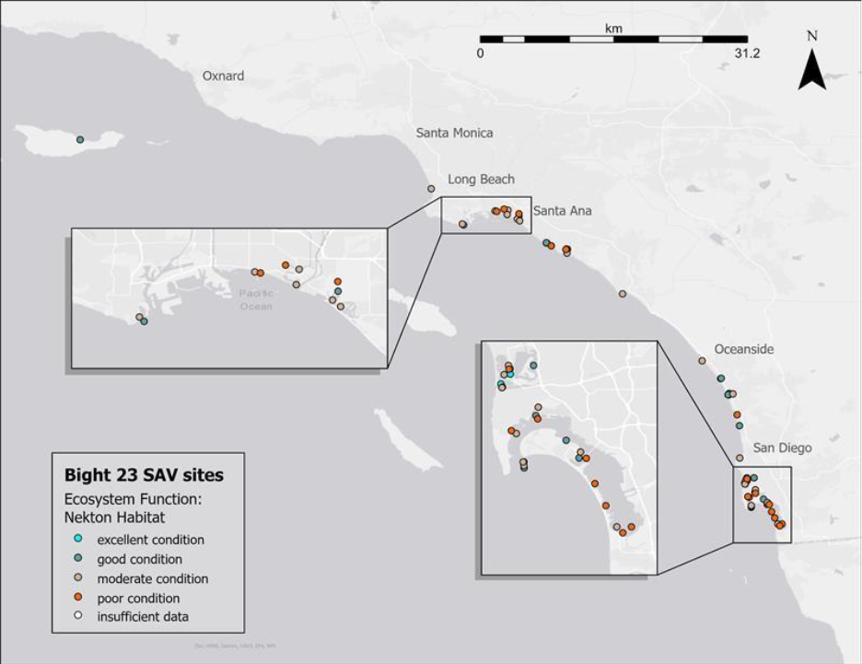
Figure C1. Geographic distribution of estimated nekton habitat ecosystem function throughout the Southern California Bight. The legend shows point color corresponding to overall eelgrass condition categories.
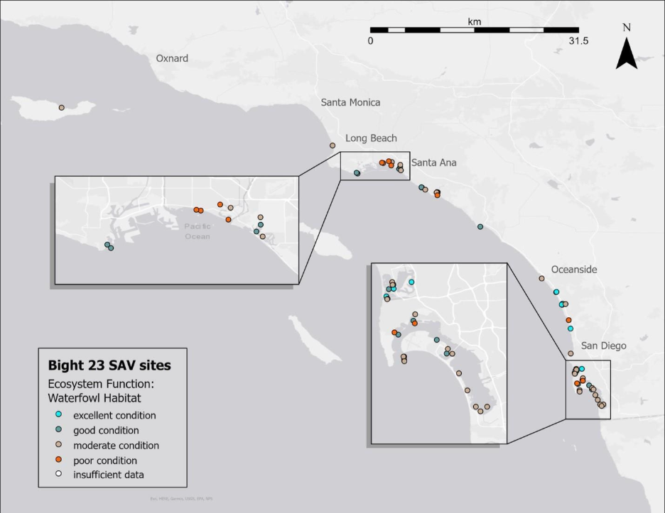
Figure C2. Geographic distribution of estimated waterfowl habitat ecosystem function throughout the Southern California Bight. The legend shows point color corresponding to overall eelgrass condition categories.
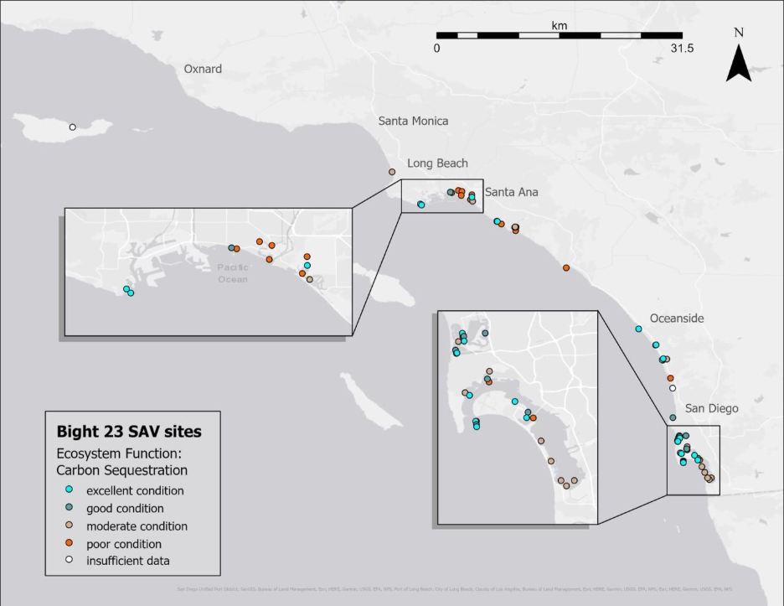
Figure C3. Geographic distribution of estimated carbon sequestration ecosystem function throughout the Southern California Bight. The legend shows point color corresponding to overall eelgrass condition categories.
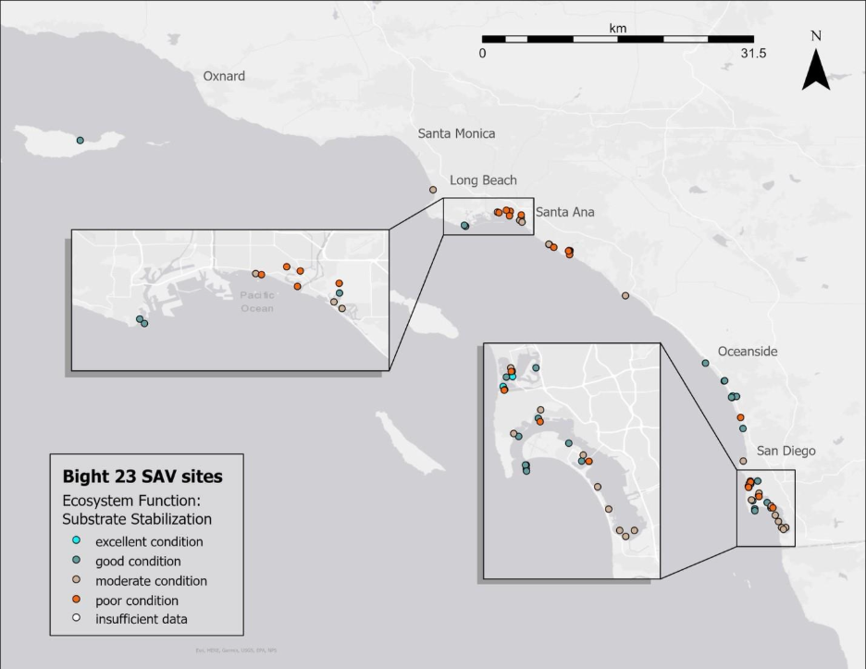
Figure C4. Geographic distribution of estimated substrate stabilization ecosystem function throughout the Southern California Bight. The legend shows point color corresponding to overall eelgrass condition categories.

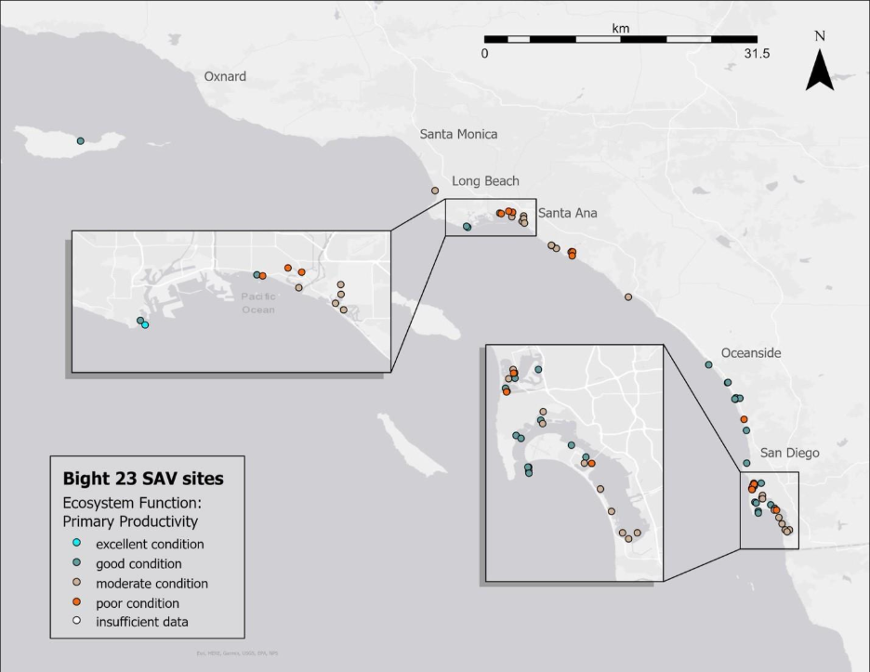
Figure C5. Geographic distribution of estimated primary production ecosystem function throughout the Southern California Bight. The legend shows point color corresponding to overall eelgrass condition categories.

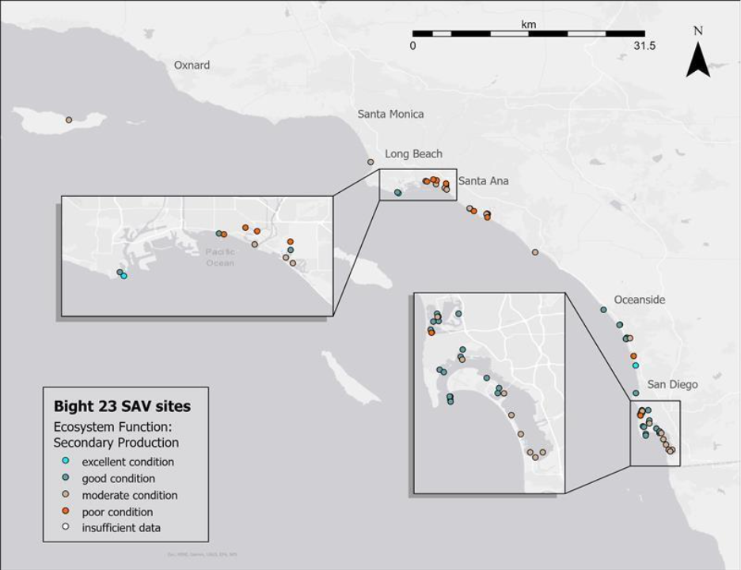
Figure C6. Geographic distribution of estimated secondary production ecosystem function throughout the Southern California Bight. The legend shows point color corresponding to overall eelgrass condition categories.

Appendix D – Exploratory Analyses
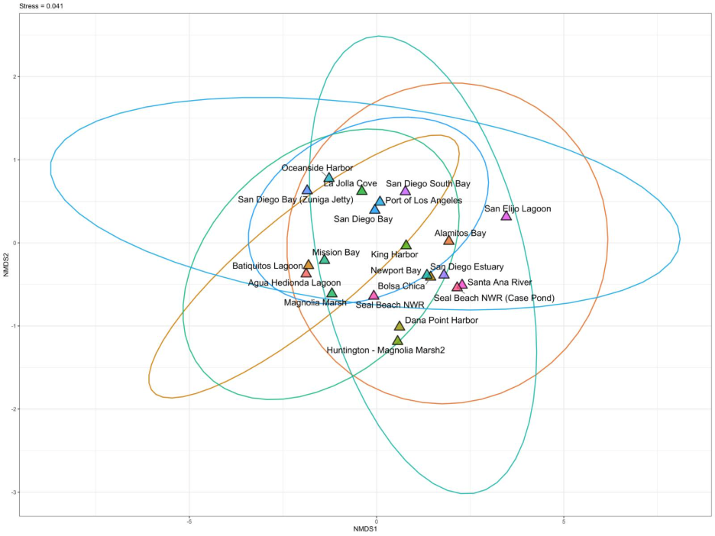
Figure D1. Non-metric multidimensional scaling plot of ecosystem function scores at each waterbody. Points represent centroids from multiple sites at each waterbody. Points and ellipses are both color-coded by waterbody. Ellipses represent 95% of the data for each waterbody. Stress = 0.041.

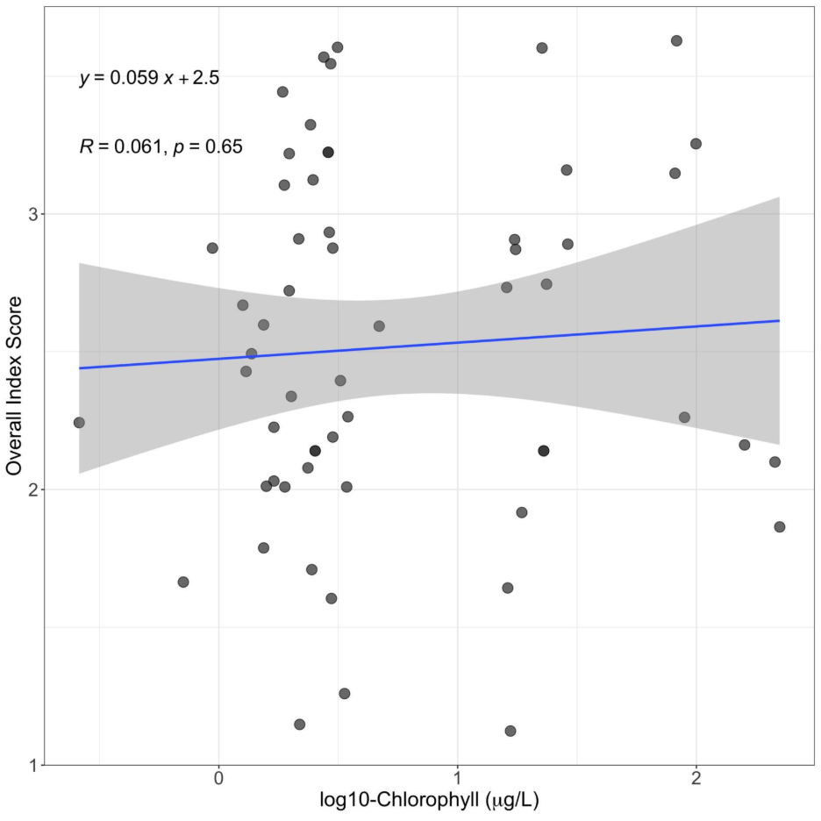
Figure D2. Log₁₀ – transformed chlorophyll a concentrations with overall eelgrass index scores. Chlorophyll data was not available for all sites. No significant relationship was observed.

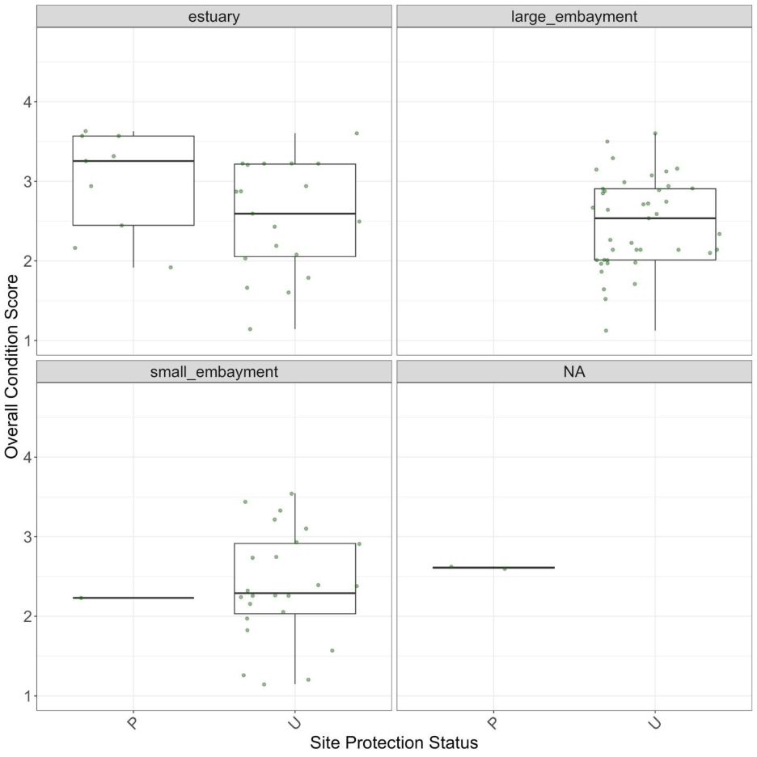
Figure D3. Overall eelgrass condition scores by nominal site protection status. P = “protected”, “U” = unprotected. Protected sites include areas within designated Marine Protected Areas (no take, limited take, State Marine Reserves, State Marine Conservation Areas). Unprotected sites are areas that are not protected from take in some way, including National Wildlife Refuges. T-test comparisons indicate no significant differences between protection status in any stratum.

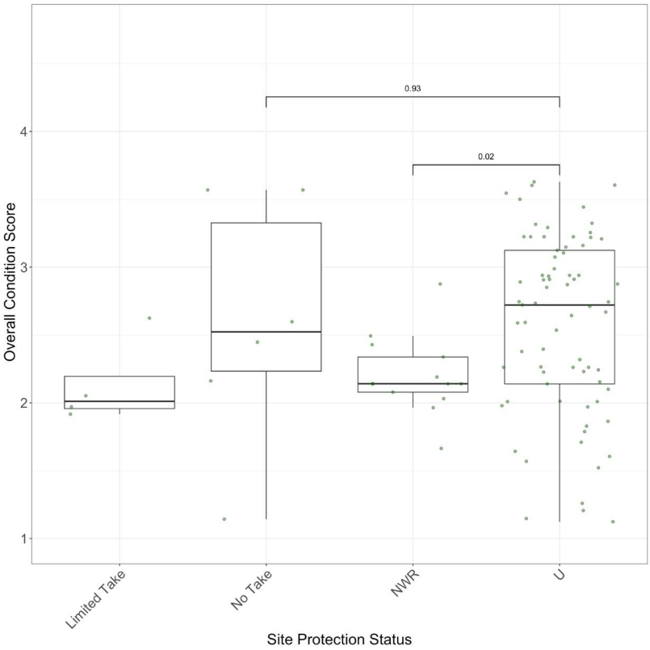
Figure D4. Overall eelgrass condition scores by specific site protection status. “No Take” = MPAs with no take, “Limited Take” = MPAs with limited take regulations, not including scientific collection, “NWR” = National Wildlife Refuges, “U” = unprotected. Wilcox test shows a significant (p = 0.02) difference between NWR and Unprotected sites.

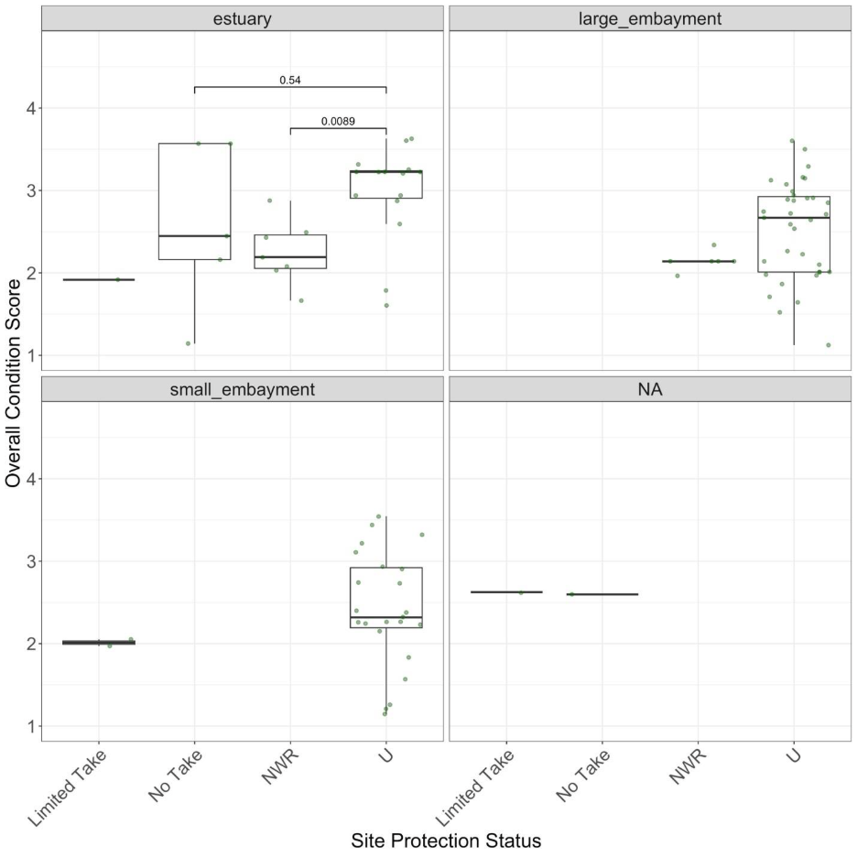
Figure D5. Overall eelgrass condition scores by specific site protection status. “No Take” = MPAs with no take, “Limited Take” = MPAs with limited take regulations, not including scientific collection, “NWR” = National Wildlife Refuges, “U” = unprotected. Wilcox test shows a significant (p = 0.0089) difference between NWR and Unprotected sites in estuaries only.

